Інструкція: код відповідає завданню є зображено на скріні під цим кодом.

#include <stdio.h>

#include <conio.h>

#include <stdlib.h>

#include <time.h>

#define Z 50

void divNum (int N, int counter, int numbers [Z]);

int NSymbol (int counter, int K, int numbers [Z]);

int main()

{

    int N, temp, counter = 0, numbers [Z], K;

    do{

    printf("Enter N number: ");

    scanf("%i", &N);

    if ( N < 0) {

            printf("Error! Number have to be positive");

            continue;

    }

    temp = N;

    do{

        temp /= 10;

        counter++;

    } while (temp != 0);

    divNum(N, counter, numbers);

    printf("Enter number K:");

    scanf("%i", &K);

    if ( K <= counter){

        printf("Result: %i", NSymbol (counter, K, numbers));

    } else{

        printf("K is too long");

    }

    break;

    }while(1);

    getch();

    return 0;

}

void divNum (int N, int counter, int numbers [Z]){

    int i;

    for (i = 0; i < counter; i ++ ){

        numbers[i] = N % 10;

        N /= 10;

    }

}

int NSymbol (int counter, int K, int numbers [Z]){

    int i;

    for (i = 0; i < counter; i++){

            if ( counter - K == i)

            {

                return numbers[i];

            }

}

}

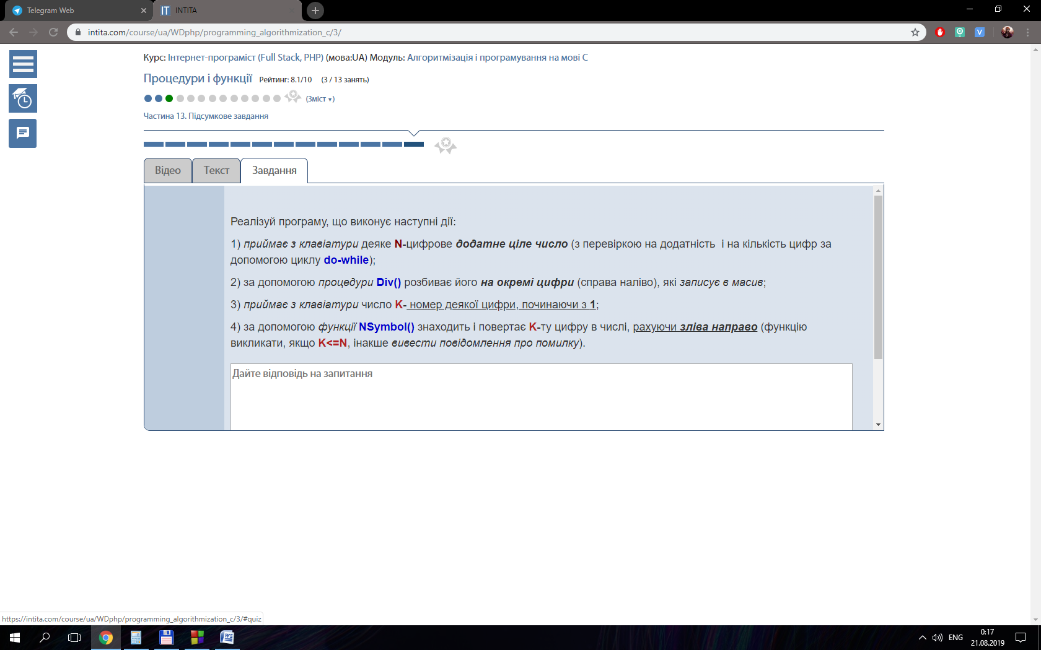

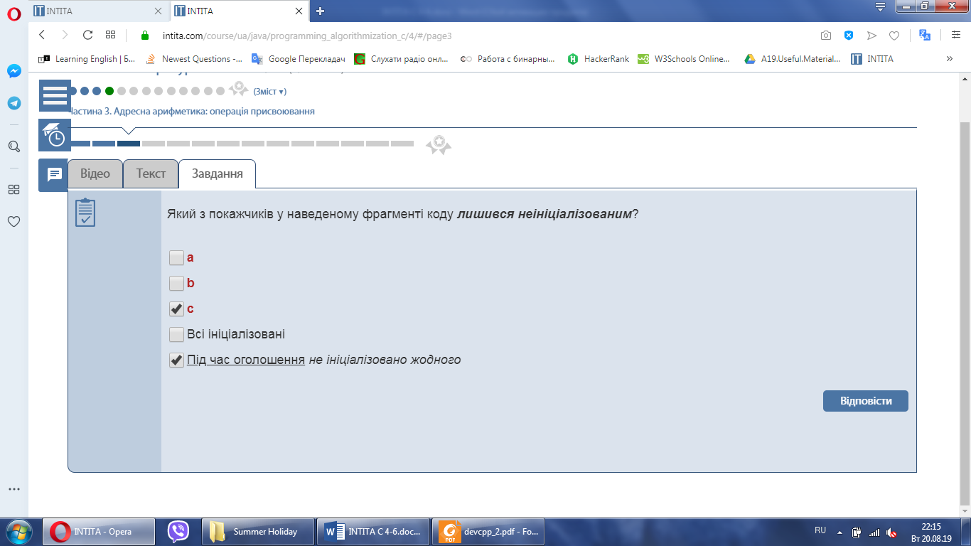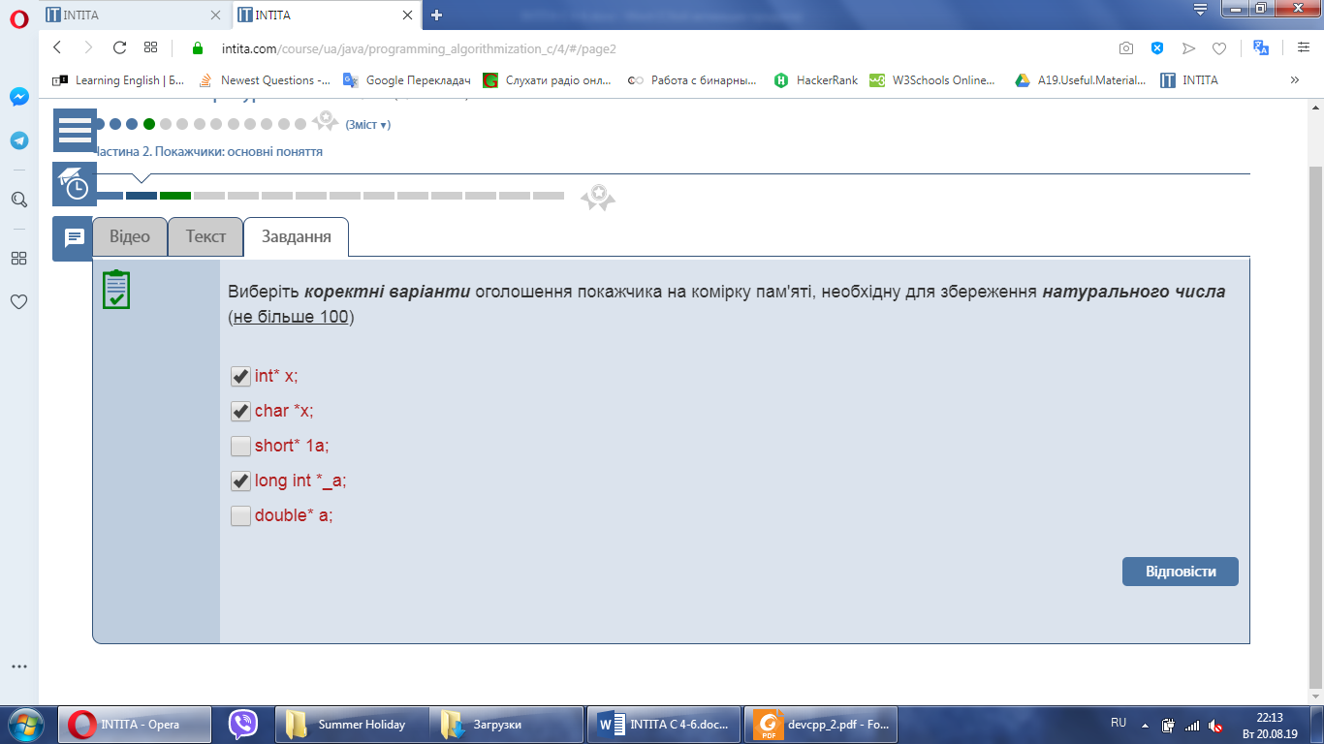

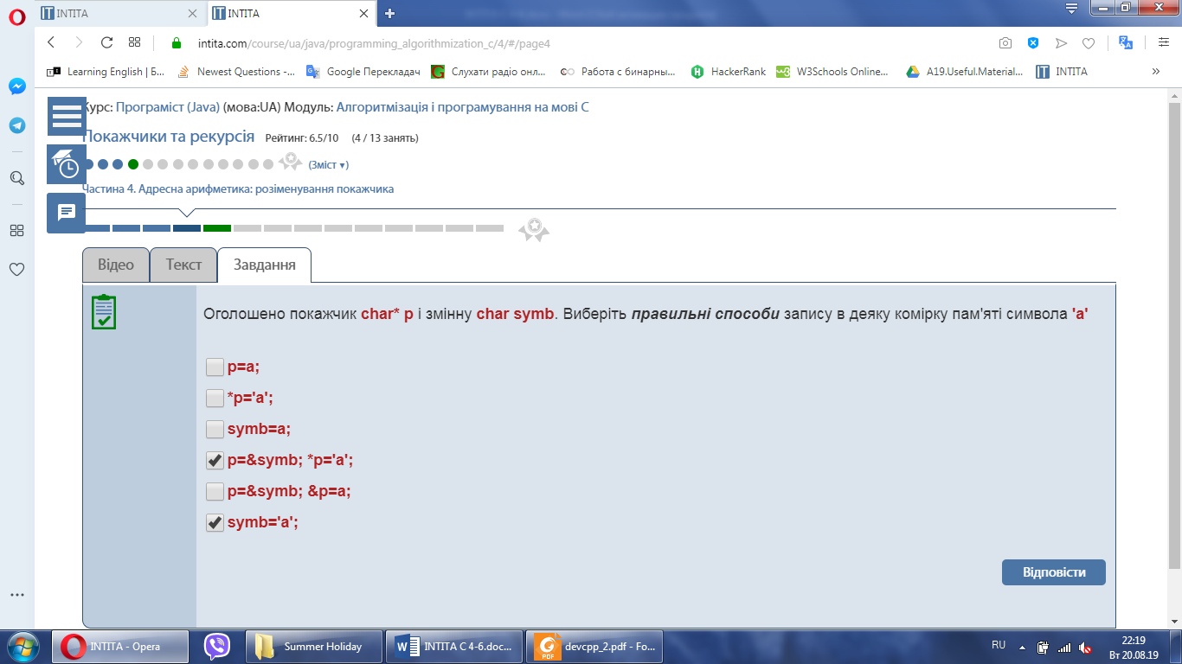

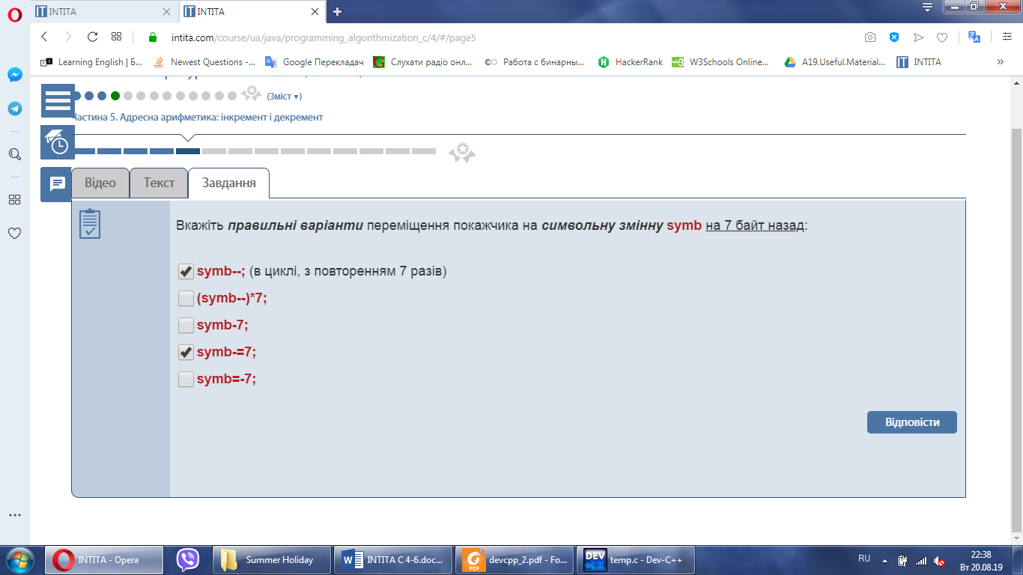

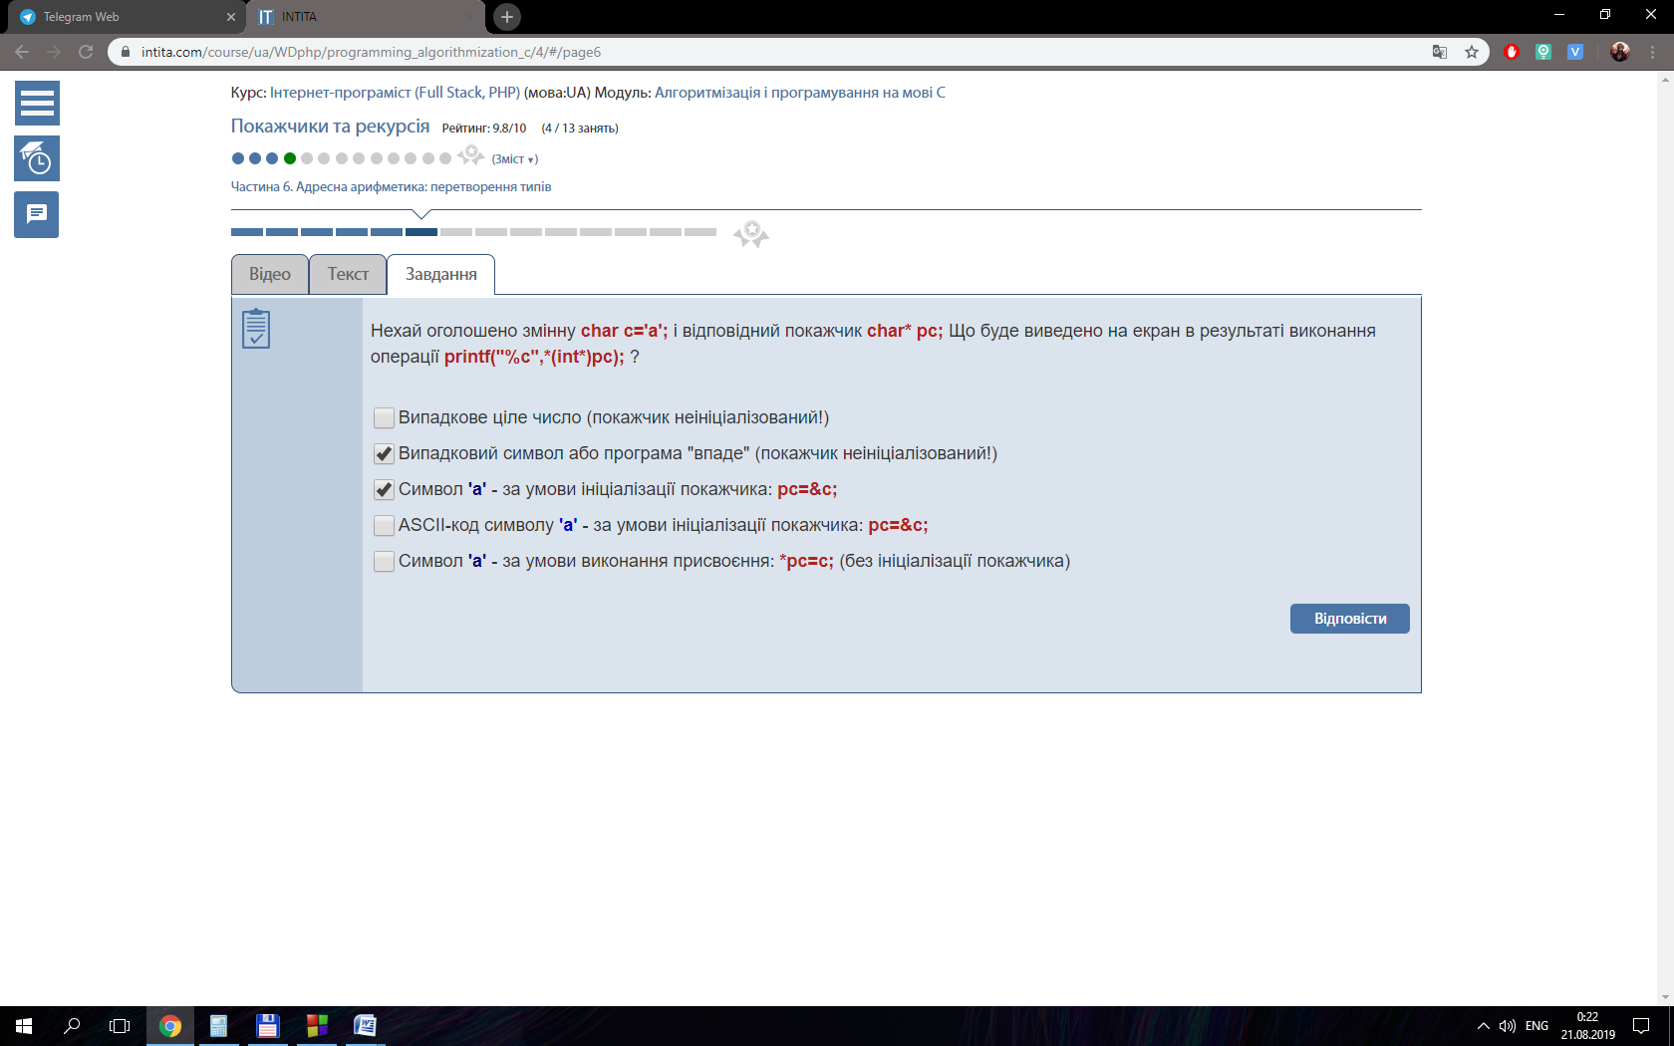

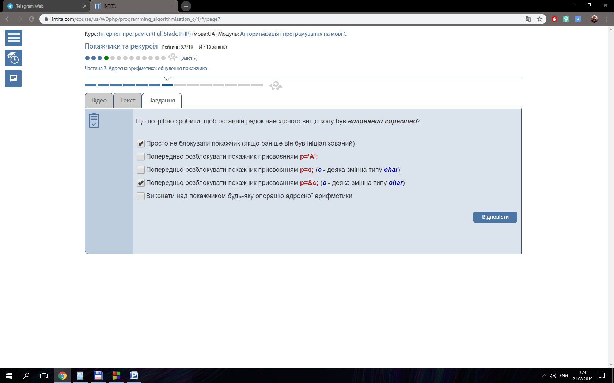

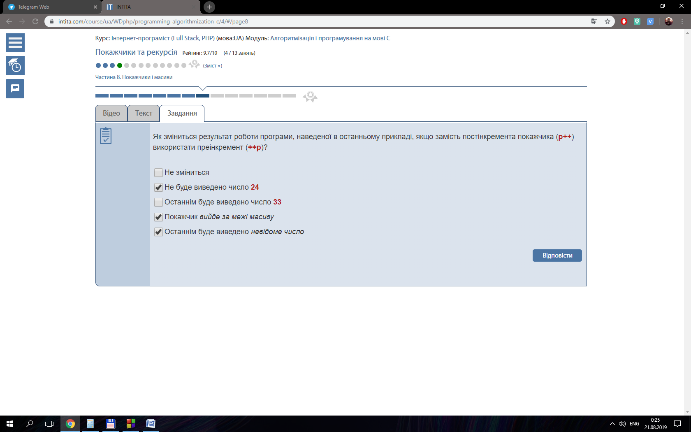

{

int i, k = 0, z = 0;

float averageMinus = 0, averagePlus = 0, min = 10000, N = 0;

for ( i = 0; i < 20; i++){

if ( arr[i] < 0){

N++;

}

}

float *arrMinus = (float*) calloc (sizeof(float), N);

float *arrPlus = (float*) calloc (sizeof(float), 20-N);

for ( i = 0; i < 20; i++){

if ( arr[i] < 0){

arrMinus [k] = arr[i];

averageMinus += arrMinus[k];

k++;

} else {

arrPlus [z] = arr[i];

averagePlus += arrPlus [z];

z++;

}

}

averageMinus /= N;

averagePlus /= 20.0 - N;

for (i = 0; i < 20; i++){

arr[i] = 0;

}

if ( abs(averageMinus) > averagePlus){

for (i = 0; i < N; i++){

if (abs(arrMinus[i] - averageMinus) < min){

min = abs(arrMinus[i] - averageMinus);

}

}

for (i = 0; i < N; i++){

if (abs(arrMinus[i] - averageMinus) == min){

arrMinus [i] = averageMinus;

}

arr[i] = arrMinus[i];

}

} else {

for (i = 0; i < 20 - N; i++){

if (abs(arrPlus[i] - averagePlus) < min){

min = abs(arrPlus[i] - averagePlus);

}

}

for (i = 0; i < 20 - N; i++){

if (abs(arrPlus[i] - averagePlus) == min){

arrPlus [i] = averagePlus;

}

arr[i] = arrPlus[i];

}

free(arrMinus);

free(arrPlus);

return arr;

}

}

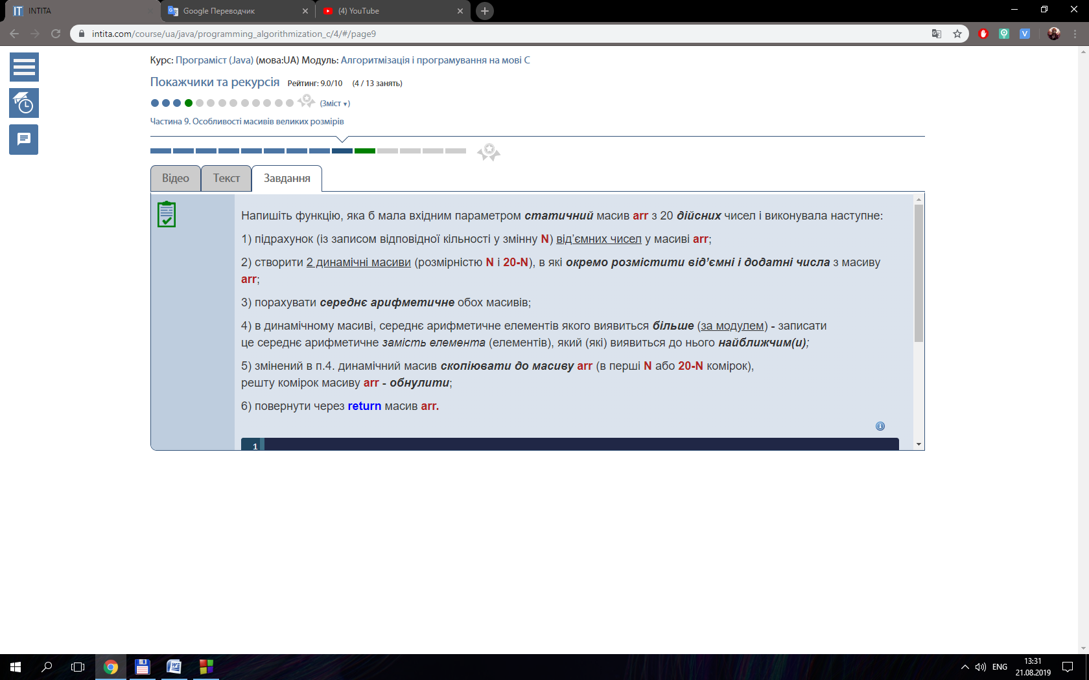

#include <stdio.h>

#include <conio.h>

int natural (int n, int N);

int main ()

{

int N;

printf("Enter last number: ");

scanf("%i", &N);

printf("\nResult = %i", natural (1, N));

getch();

return 0;

}

int natural (int n, int N){

if ( n == N){

printf("%i ", n);

return n;

}

printf("%i ", n);

return natural(n + 1, N);

}

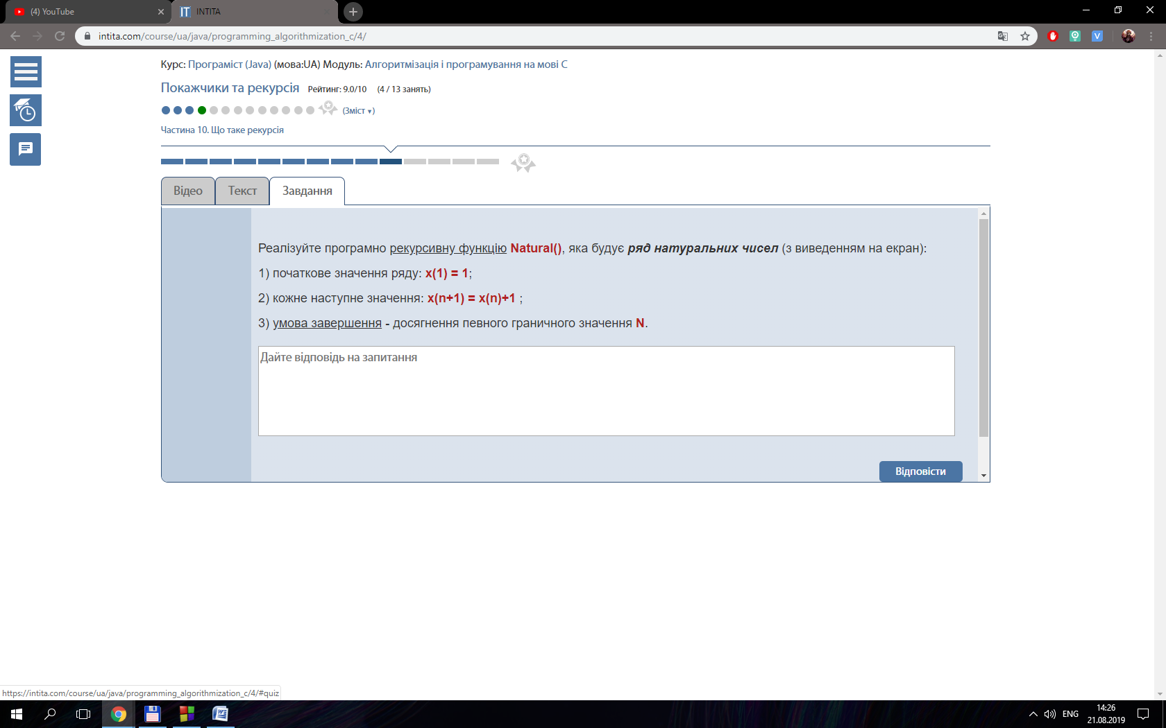

#include <stdio.h>

#include <conio.h>

#include <time.h>

#include <stdlib.h>

#define N 10

int numNum (int i, int ourElem, int arr[N]);

int main ()

{

    srand(time(NULL));

    int arr[N], ourElem, i;

    for ( i = 0; i < N; i++){

        arr[i] = rand() % 10;

        printf("%i ", arr[i]);

    }

    printf("\nEnter necessary number: \n");

    scanf("%i", &ourElem);

    printf("\nResult = %i", numNum(0, ourElem, arr));

    getch();

    return 0;

}

int numNum (int i, int ourElem, int arr[N]){

    if ( i == N ){

        return 0;

    }

    if ( arr[i] == ourElem){

        return 1 + numNum(++i, ourElem, arr);

    }

    return numNum(++i, ourElem, arr);

}

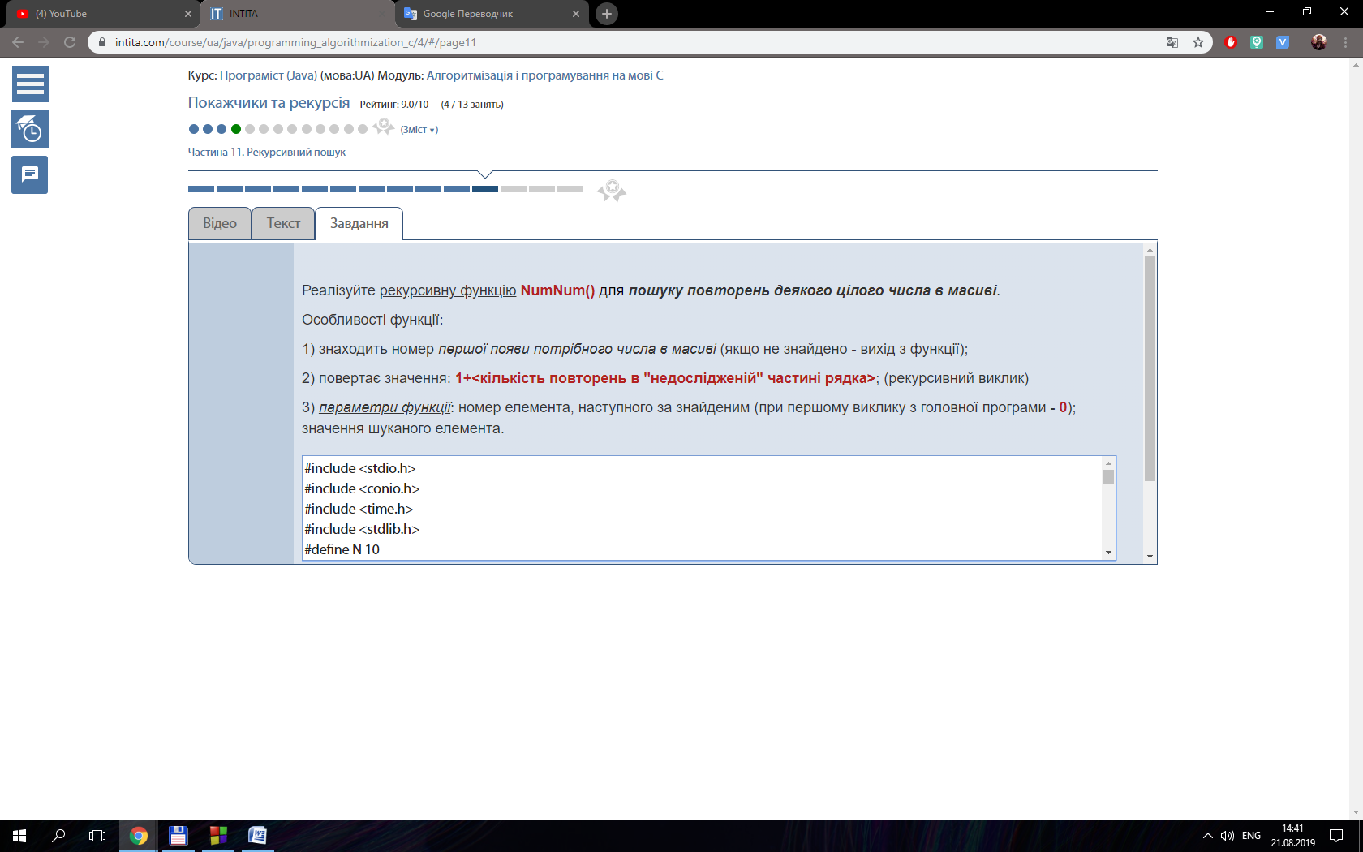

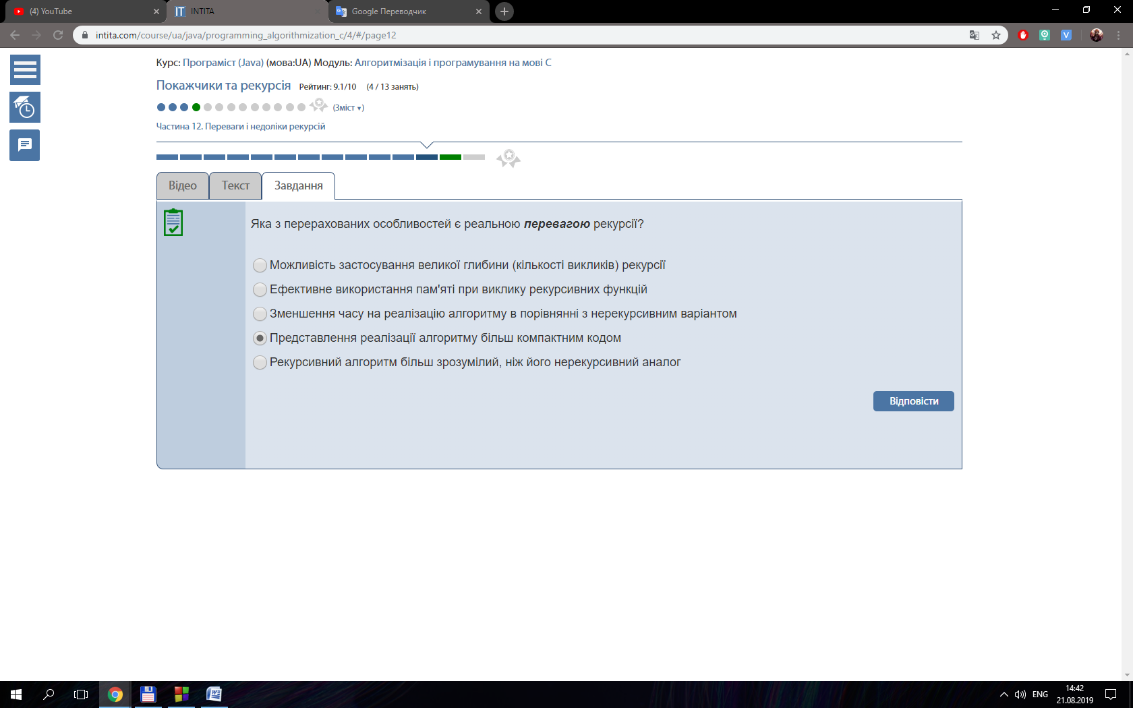

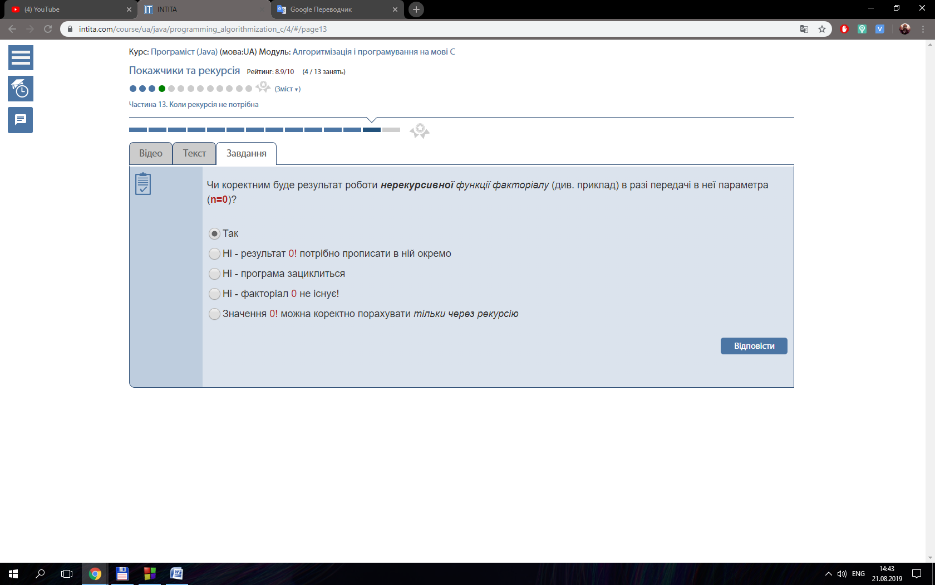

#include <stdio.h>

#include <stdlib.h>

#include <string.h>

#include <math.h>

int rowNumbers (int endSum, int sum, int i);

int main()

{

int *sum, endSum, N, i;

printf("Enter end sum of numbers: ");

scanf("%i", &endSum);

N = rowNumbers(endSum, 1, 1);

printf("result = %i\n", N);

sum = (int *) calloc(sizeof(int), N);

sum [0] = 1;

printf("%i\n", sum[0]);

for (i = 1; i < N; i++){

sum[i] = (1 + i) + sum [i - 1];

printf("%i\n", sum[i]);

}

return 0;

}

int rowNumbers (int endSum, int sum, int i){

if (sum > endSum){

return i - 1;

}

return rowNumbers(endSum, sum +=i, ++i );

}

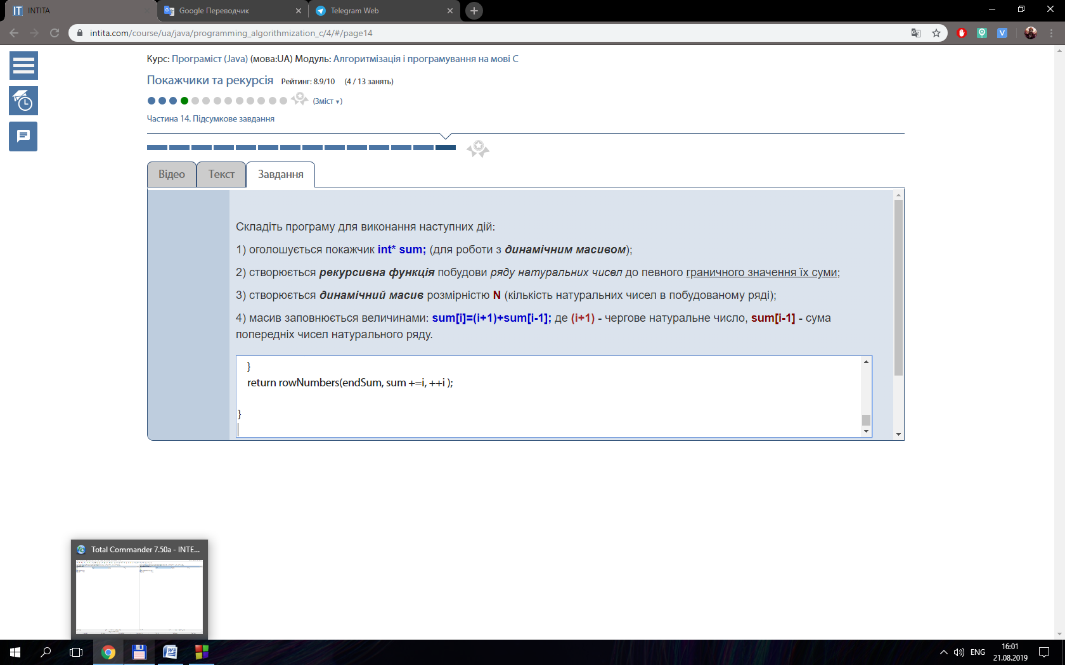

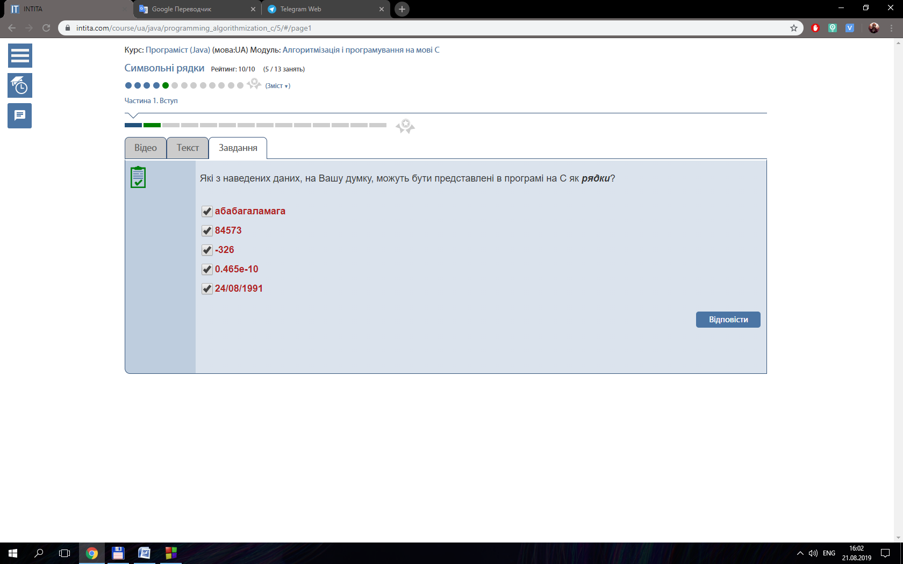

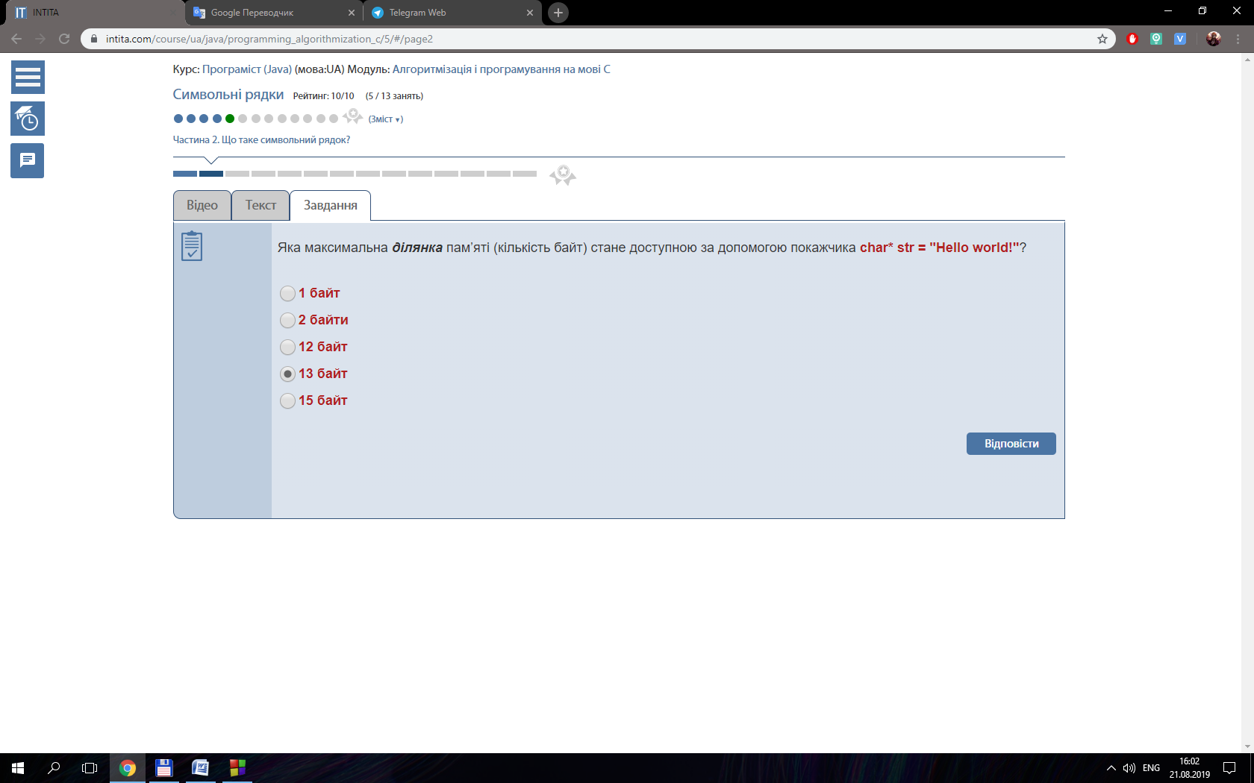

#include <stdio.h>

#include <stdlib.h>

#include <conio.h>

#define MAX 80

int main()

{

    char *str = (char*) calloc ( sizeof ( char ), MAX );

    char temp;

    int i = 0;

    printf ( "Input string: " );

    gets ( str );

    printf ( "You`ve input: " );

    while ( i != MAX - 1 )

    {

        temp = * ( str + i );

        if ( temp == 0 ) break;

        printf ( "%c", temp );

        i++;

    }

    free(str);

    return 0;

}

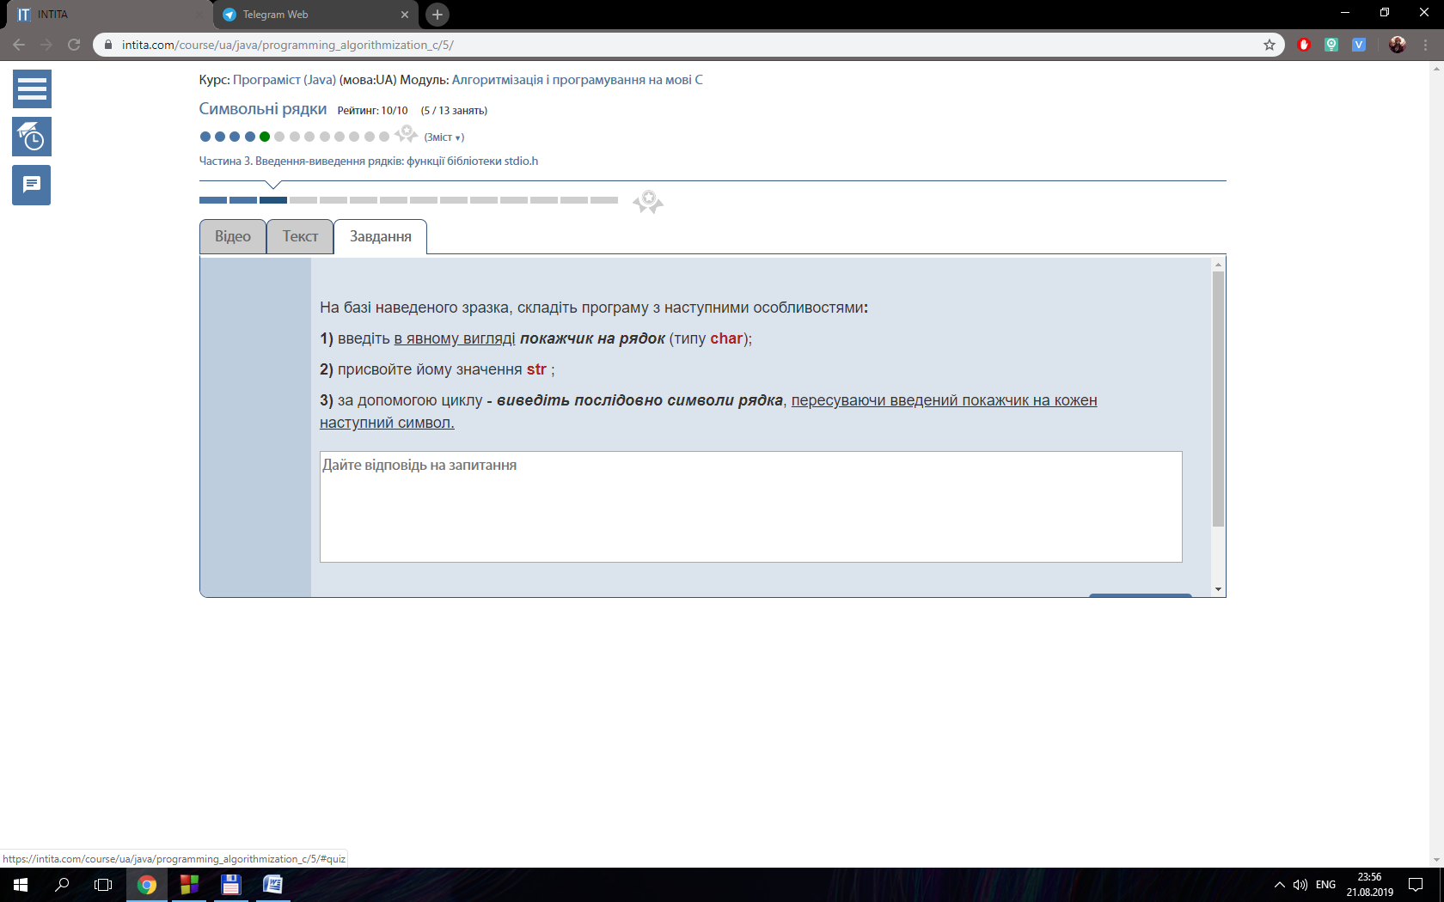

#include <iostream>

#include <string>

#include <iomanip>

int main()

{

    const int MAX = 80;

    //int i;

    char str[MAX];

    std::cout << "Input string: ";

    std::cin >> std::setw(MAX) >> str;

    std::cout << "You’ve input: " << str << std::endl;

    std::cout << "You’ve input (another way): ";

    for (int i = 0; i < MAX - 1; i++){

     if ( *(str + i) == 0) break;

     std::cout << *(str + i);

 }

    return 0;

}

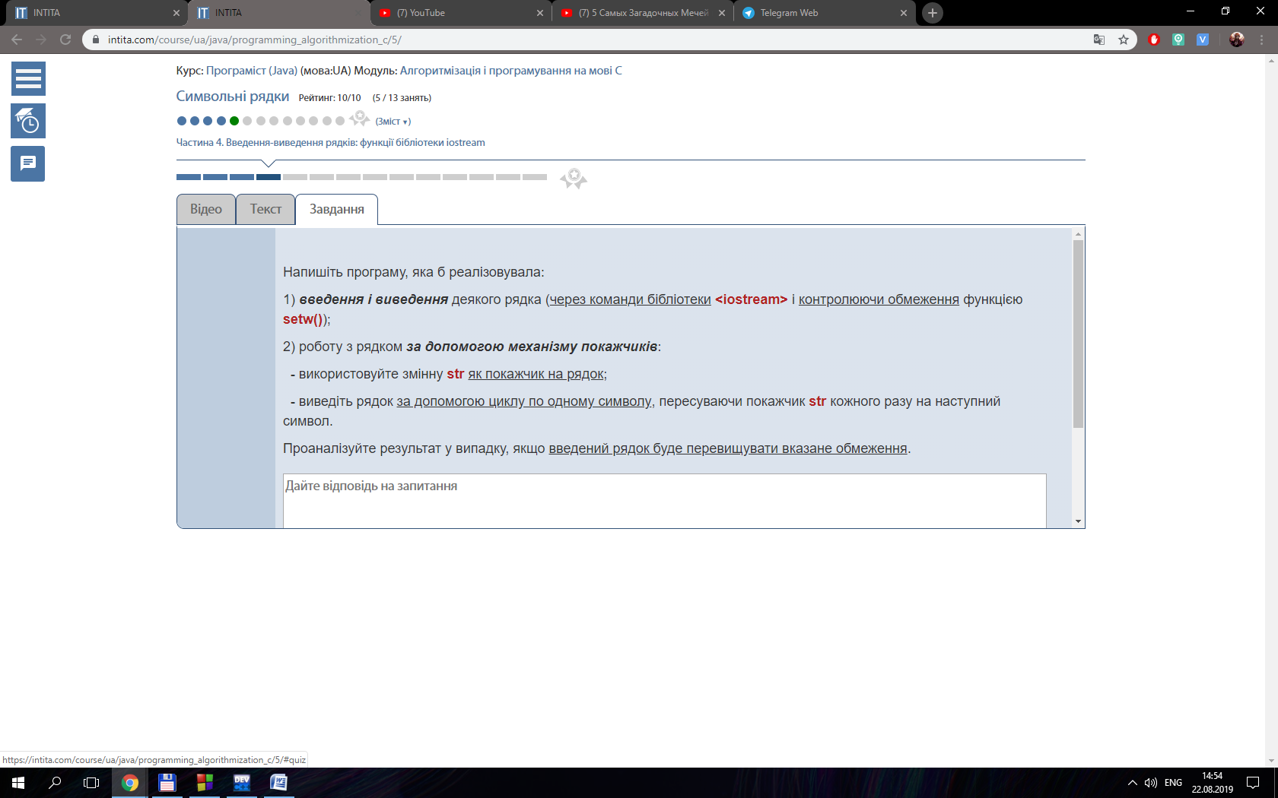

#include <stdio.h>

#include <string.h>

#include <conio.h>

#define MAX 80

int main()

{

    printf("Enter string: ");// підказка

    char string[MAX];

    gets(string);

    puts(string);

    getch();

    return 0;

}

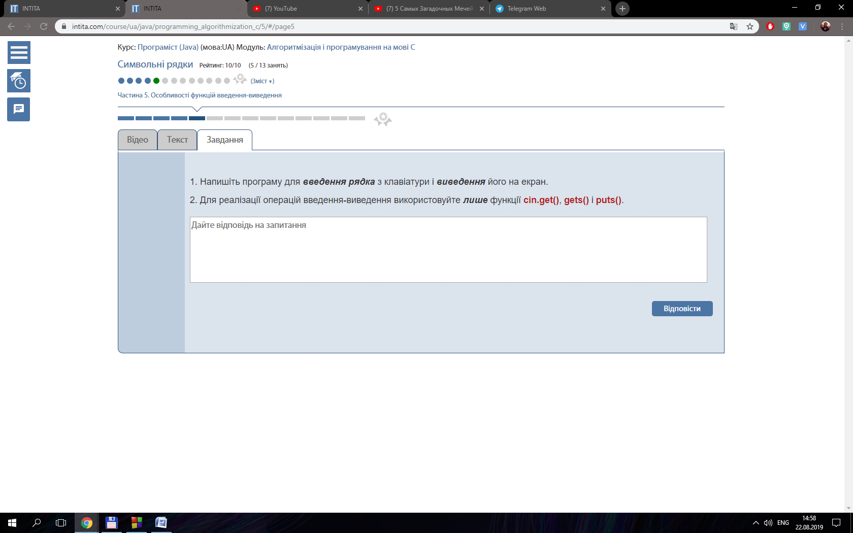

{

    char *ps ;

    ps = &str[0];

    int i = 0, numPos = -1;

    while (1){

        if ( *(ps + i) == 0) break;

        if ( *(ps + i) == 'y'){

            numPos = i;

        }

        i++;

    }

    return numPos;

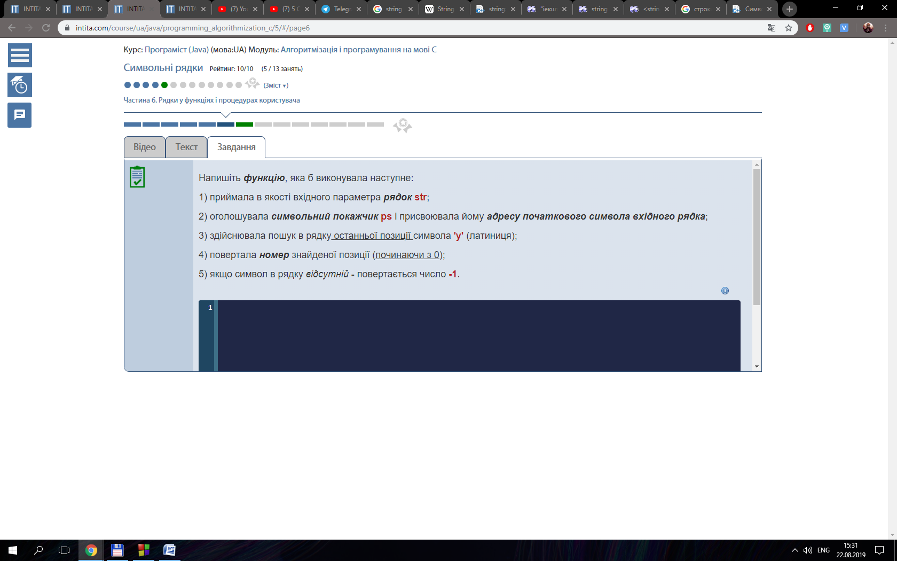}

#include <stdio.h>

#include <malloc.h>

#include <conio.h>

#include <string.h>

int main ()

{

    int maxLength, lengthRow;

    printf ( "Enter max length: " );

    scanf ( "%i", &maxLength );

    fflush(stdin);

    char str [1000];

    do {

        printf("Enter row: ");

        gets(str);

        lengthRow = strlen(str);

        printf("Length of row: %i\n", lengthRow);

    } while (maxLength > lengthRow);

    getch();

    return 0;

}

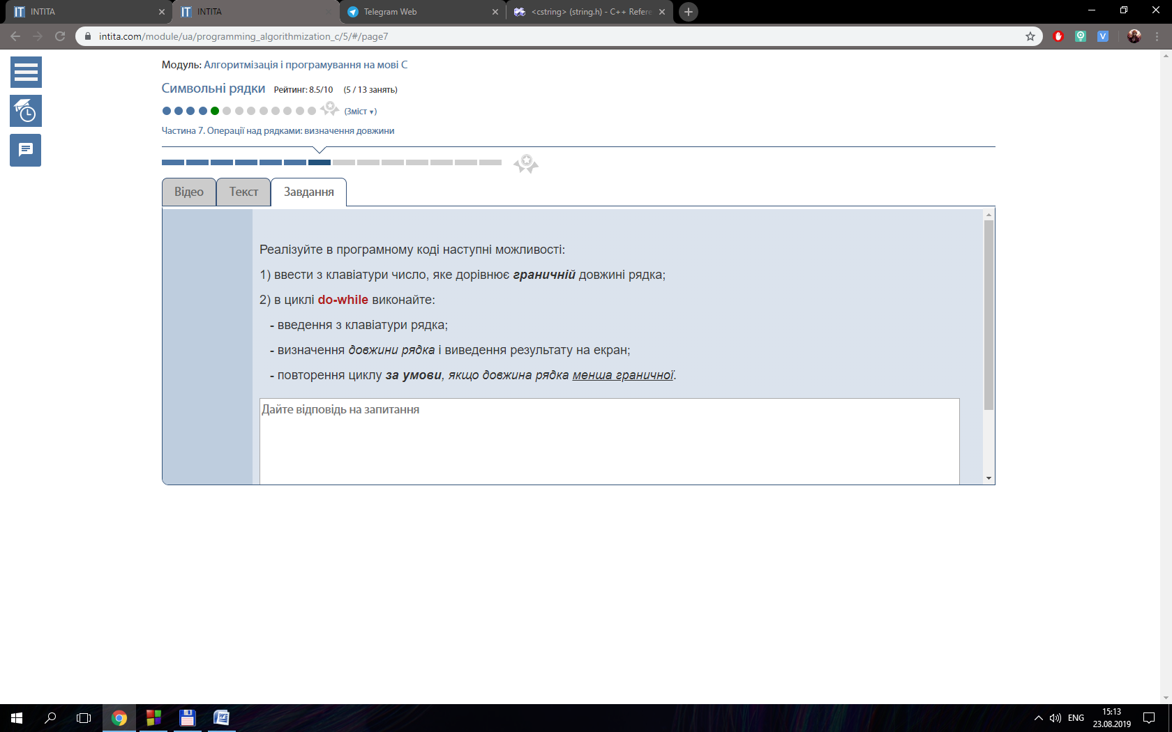

#include <stdio.h>

#include <conio.h>

#include <string.h>

int main()

{

    int n, result;

    char str1 [] = "Australia";

    char str2 [] = "Austria";

    do{

        printf("Enter the number of characters to check: ");

        scanf("%i", &n);

        result = strncmp(str1, str2, n);

        if (result == 0){

            printf("Match");

        } else{

            printf("Doesn't match\n");

        }

    } while (result != 0);

    return 0;

}

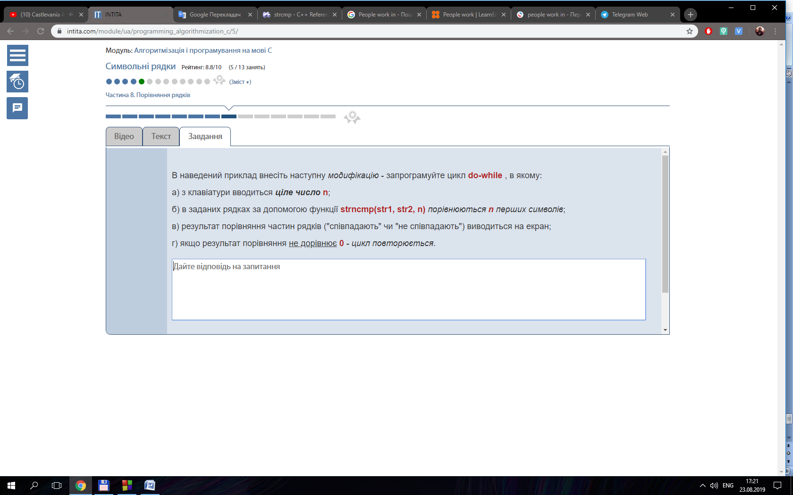

{

    char *s1, *s2;

    s1 = &str1[0];

    s2 = &str2[0];

    if (7 < n ){

        return "Error";

    } else {

        strcpy ( s1 + n, s2);

        return s1;

    }

}

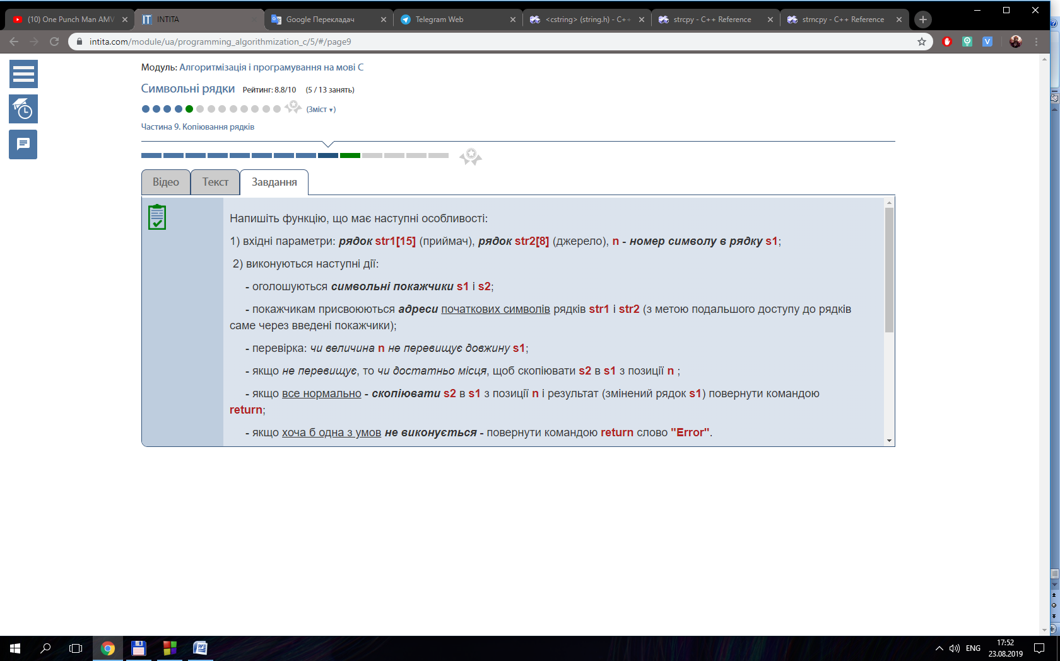

{

    char *s1, *s2;

    s1 = &str1[0];

    s2 = &str2[0];

    if (8 < n ){

        return "Error";

    }

        strncpy ( s1 , s2, n);

       s1[n] = '\0';

        return s1;

}

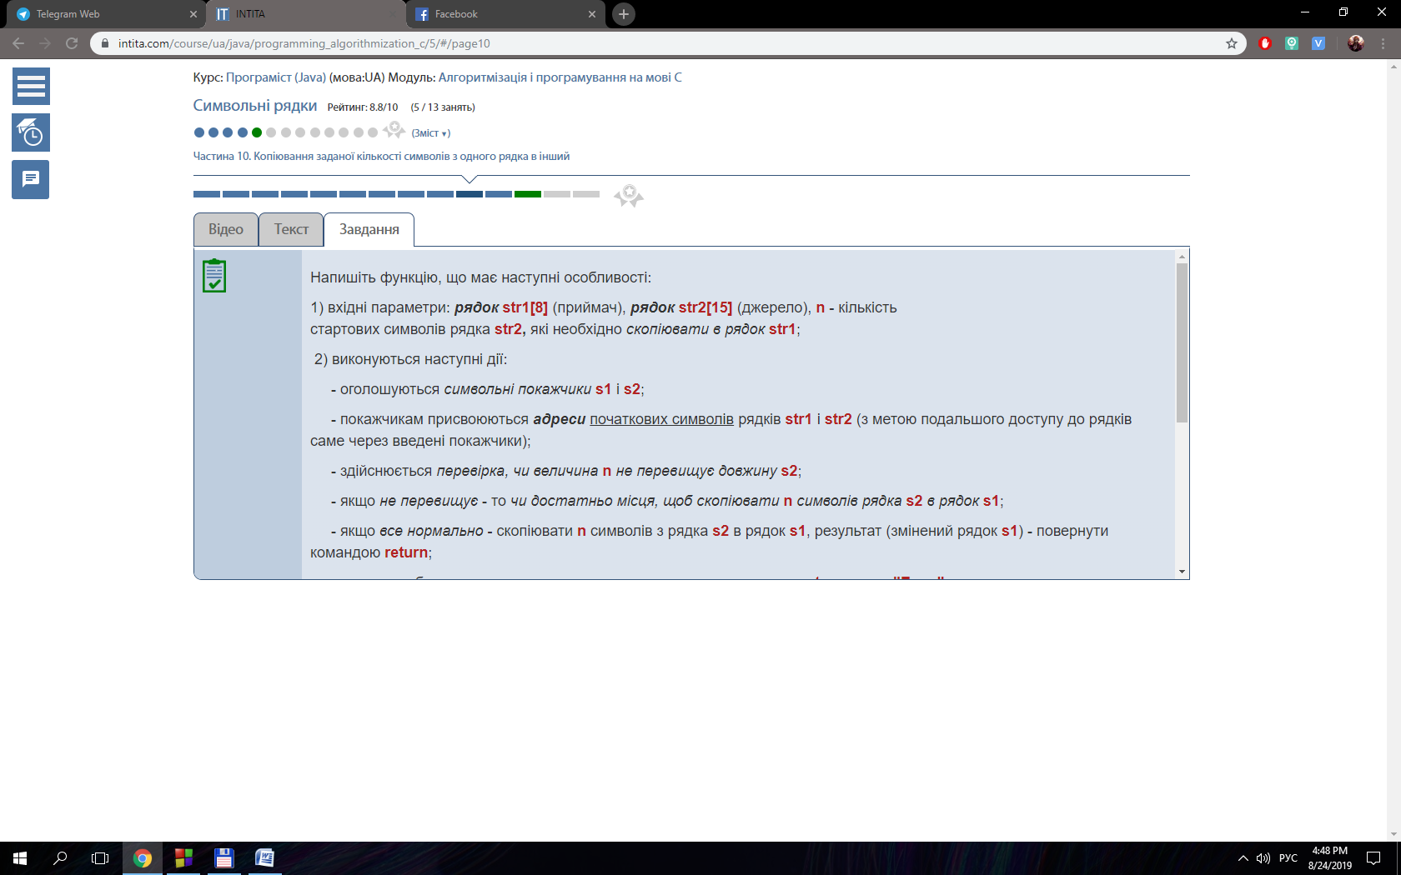

#include <stdio.h>

#include <conio.h>

#include <string.h>

#define MAX 100

int main()

{

    char s1[MAX], s2[MAX];

    do{

    printf("Enter string s1: ");

    gets(s1);

    printf("Enter string s2: ");

    gets(s2);

    if (strlen(s1) + strlen(s2) < MAX){

        strcat(s1, s2);

        printf("Result: ");

        puts(s1);

        break;

    }

    } while (1);

    getch();

    return 0;

}

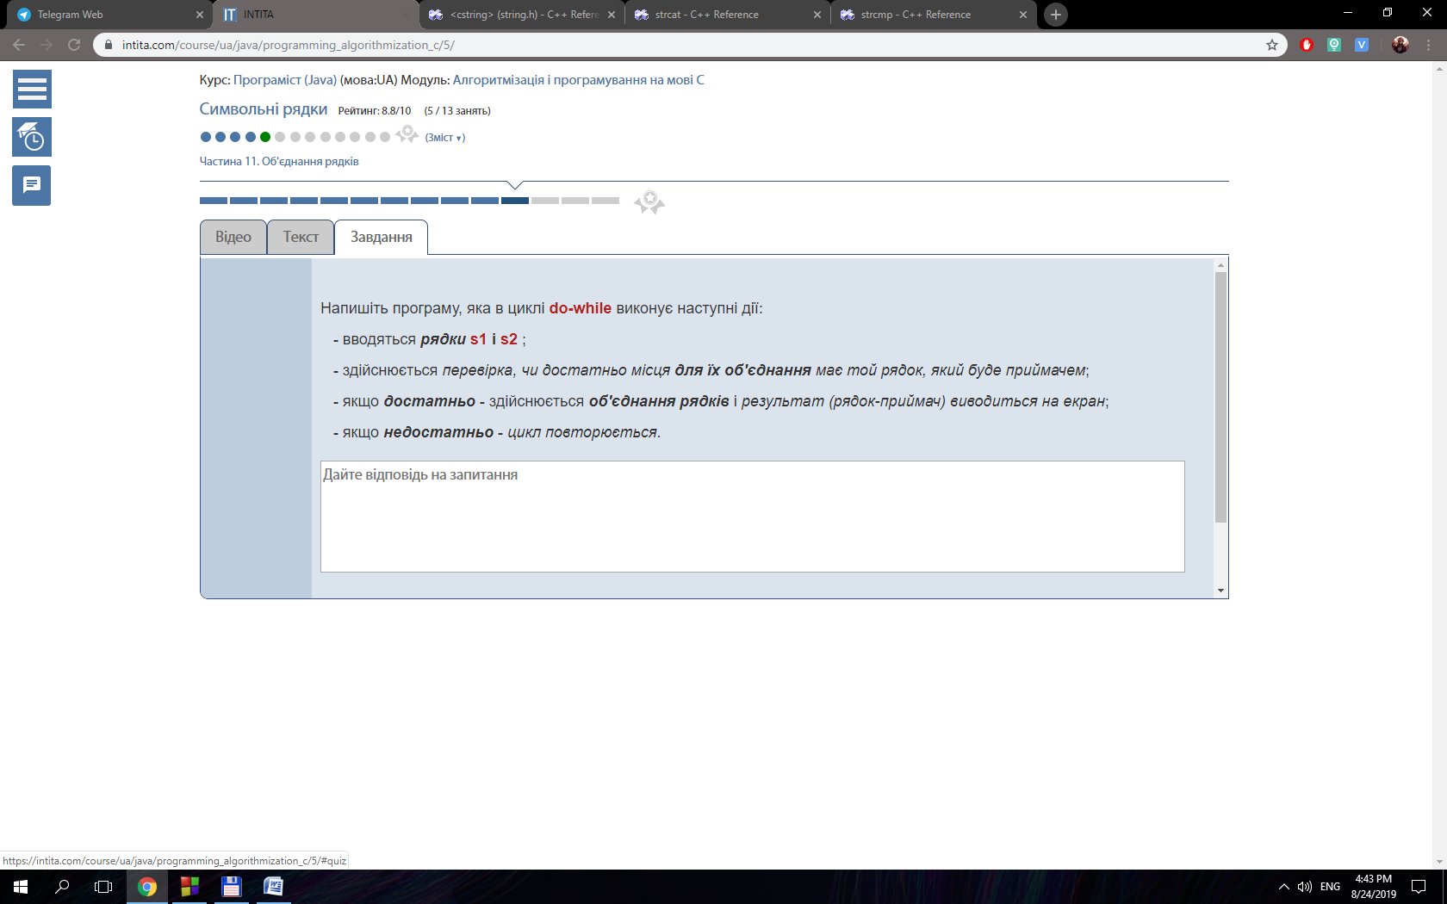

char* ps1 = &str1[0];

 char* ps2 = &str2[0];

 char* p = strstr(ps1,ps2);

 int* pos = (int*)malloc(2*sizeof(int));

 pos [0] = p-ps1;

 pos[1]=pos[0];

 int i;

 int start = pos [0]+1;

 for (i = start; i< strlen(ps1); i++)

 {

  if (p = strstr(ps1+start,ps2))

  {

   pos [1] = p-ps1;

  }

  start = pos [1];

 }

 return pos;

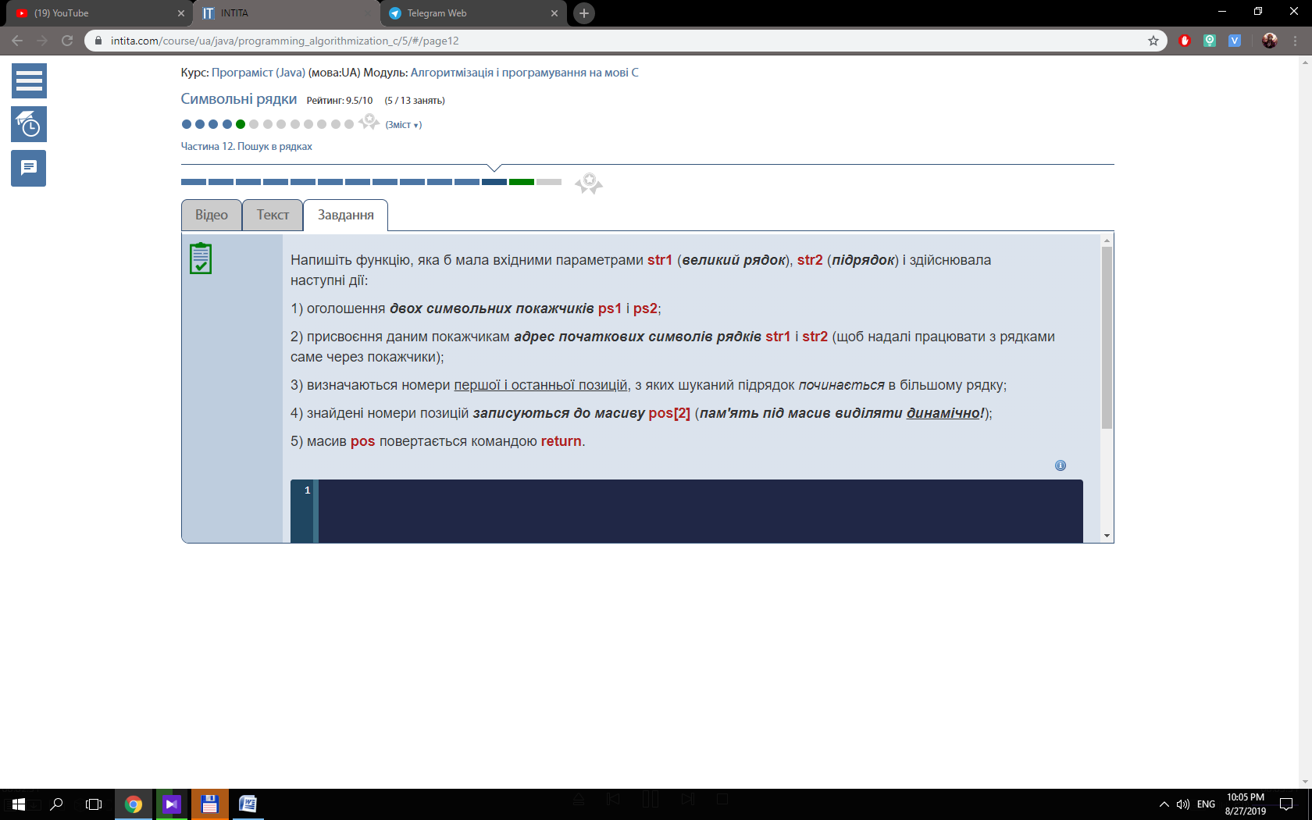

#include <stdio.h>

#include <conio.h>

int main()

{

float num1, num2;

int temp1, temp2;

printf("Enter two float number: ");

scanf("%f %f", &num1, &num2);

temp1 = num1;

temp2 = num2;

char str [20];

sprintf(str, "%d %d", temp1, temp2);

puts(str);

num1 = num2 = 0;

sscanf(str, "%g %g", &num1, &num2);

printf("num1 = %g, num2 = %g", num1, num2);

getch();

return 0;

}

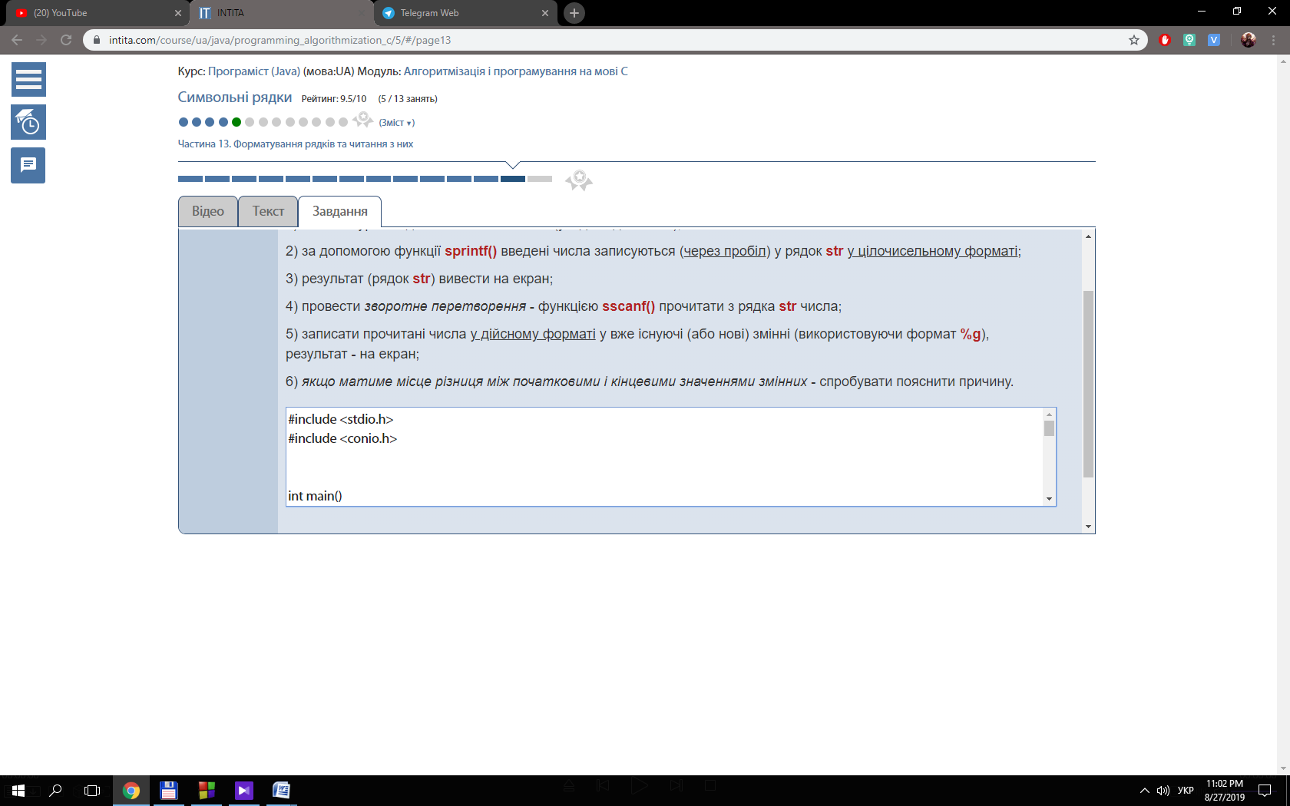

#include <stdio.h>

#include <stdlib.h>

#include <string.h>

#include <conio.h>

#define N 50

void charCopy (int n1, int n2, char str1[N], char str2 [N]);

void groupCopy (int n1, int n2, char str1[N], char str2 [N]);

int main()

{

    char str1 [N];

    char str2 [N];

    char choice;

    int n1, n2;

    printf("Enter string 1: ");

    gets(str1);

    printf("Enter string 2: ");

    gets(str2);

    do{

        printf("Enter two numbers (< length of strings): ");

        scanf("%i %i", &n1, &n2);

    } while (n1 > strlen(str1) || n2 > strlen(str2));

    do{

        printf("What method for copy do you want to use? ( 1 - char; 2 - group): \n");

        choice = getch();

        switch (choice){

            case '1': {

                charCopy(n1, n2, str1, str2);

                break;

            }

            case '2': {

                groupCopy (n1, n2, str1, str2);

                break;

            }

            default:{

                printf("You made wrong choice!\n");

                break;

            }

        }

        printf("Do you want to try again? Press 1 to try again.\n");

        choice = getch();

    } while ( choice == '1');

    getch();

    return 0;

}

void charCopy (int n1, int n2, char str1[N], char str2 [N]){

    char *str3 = (char *) calloc (sizeof(char), n1 + n2);

    int i;

    for (i = 0; i < n1 ; i++){

        *(str3 + i) = *(str1 + i);

    }

    for (i = 0; i < n2; i++){

        *(str3 + n1 + i) = *(str2 + (strlen(str2) - n2 + i));

    }

    puts(str3);

    free(str3);

}

void groupCopy (int n1, int n2, char str1[N], char str2 [N]){

    char *str3 = (char *) calloc (sizeof(char), n1 + n2);

    strncpy(str3, str1, n1);

    strncpy((str3 + n1), (str2 + (strlen(str2) - n2 )), n2);

    puts(str3);

    free(str3);

}

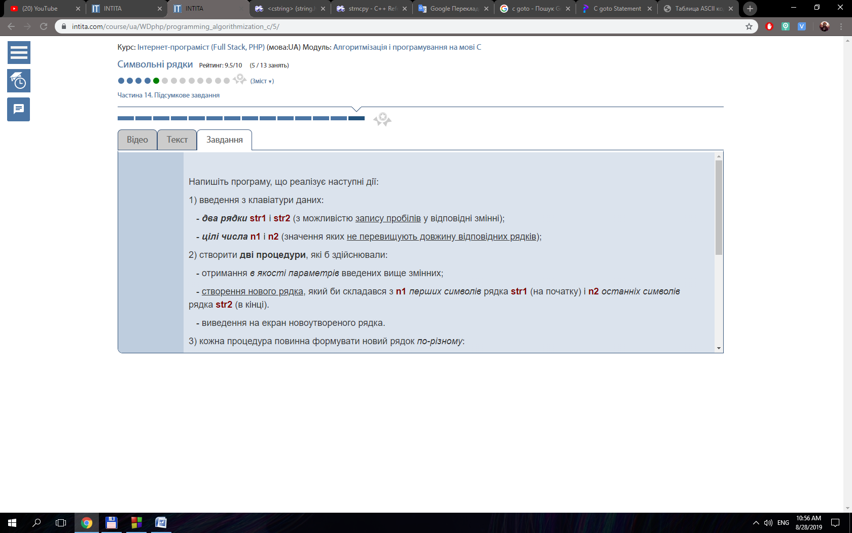

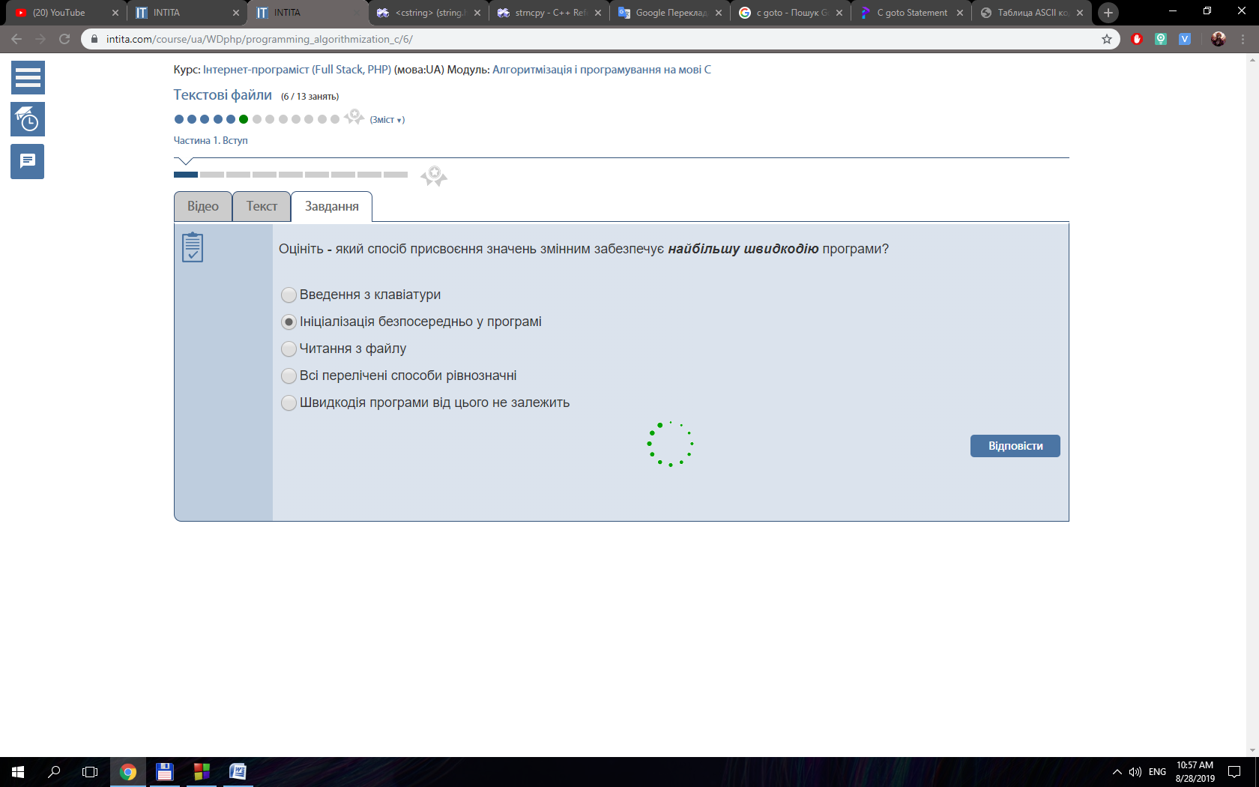

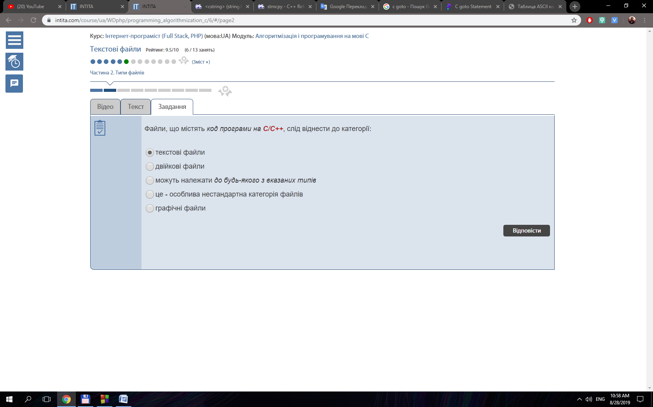

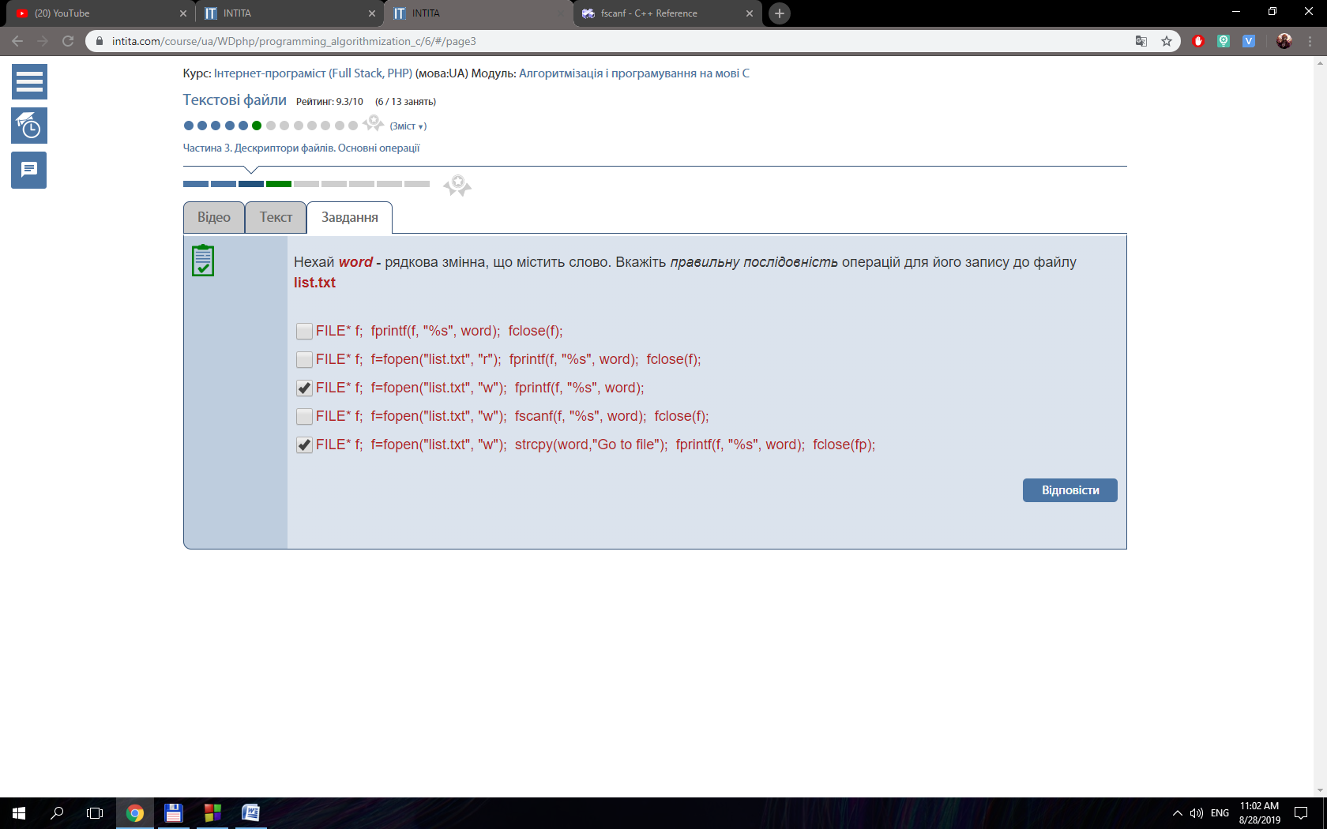

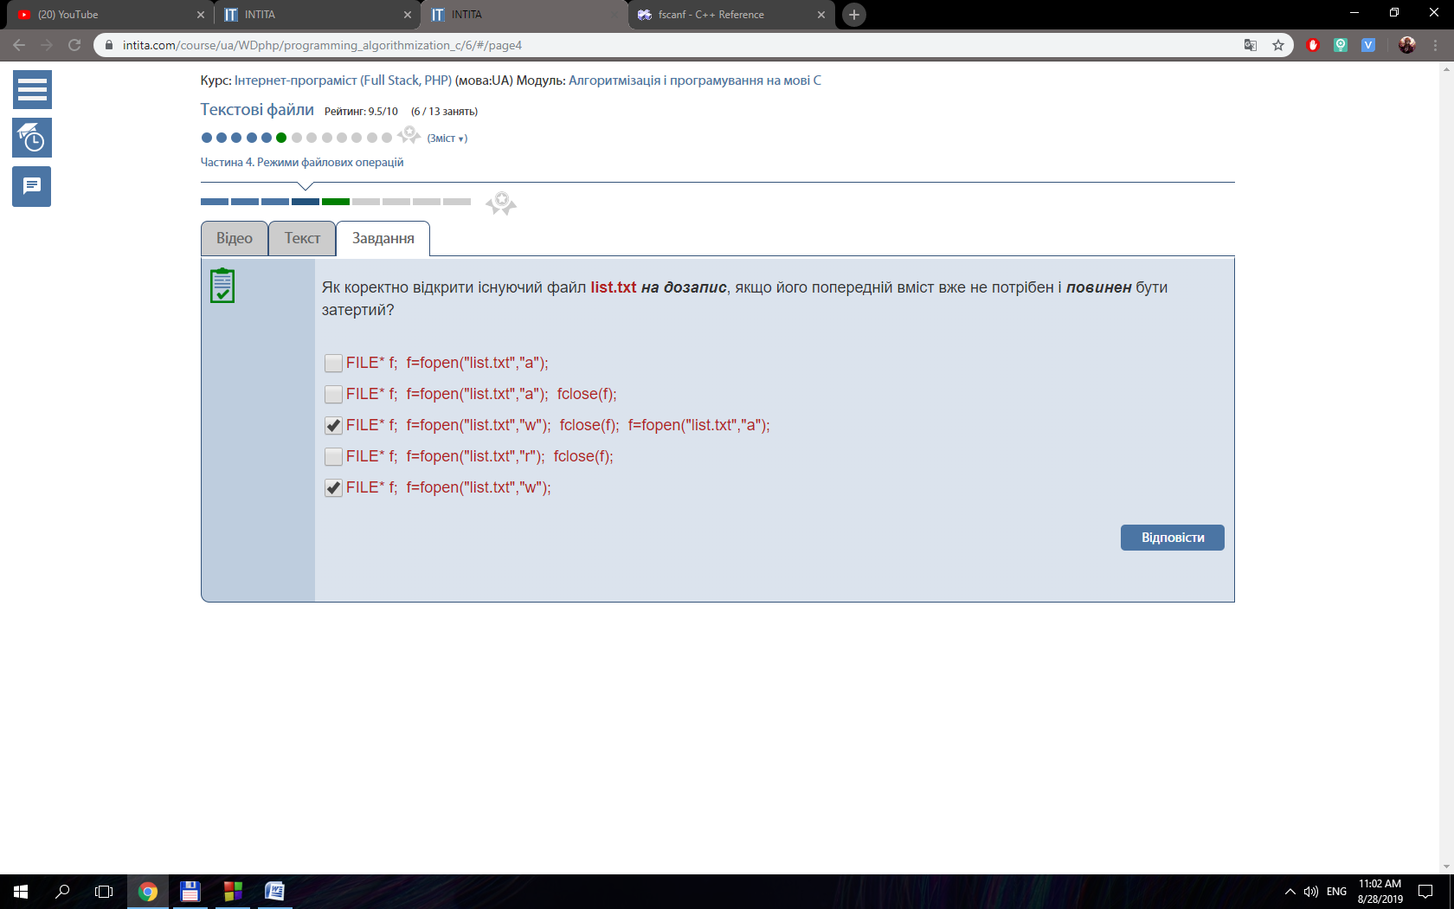

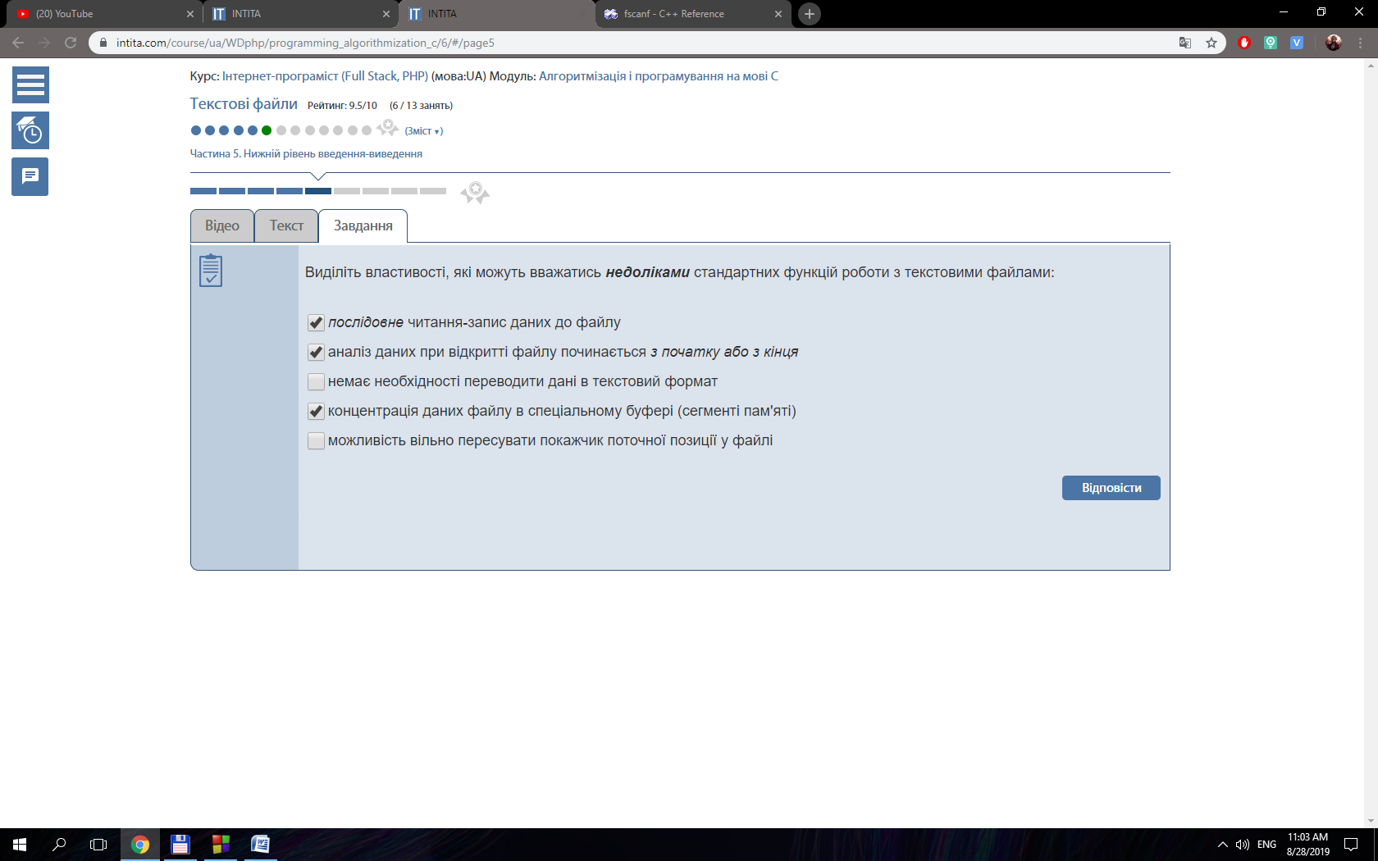

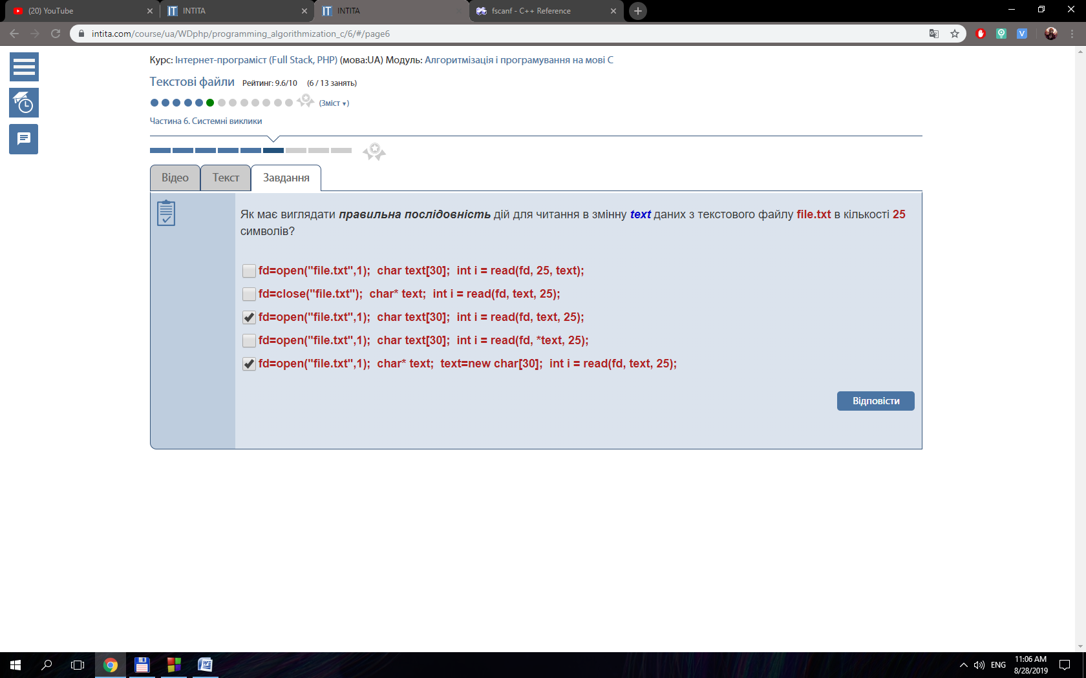#include <stdio.h>

#include <string.h>

#include <conio.h>

int main()

{

FILE *input = fopen("input.txt", "r");

FILE *output = fopen("output.txt", "w");

int num1, num2, num3;

fscanf(input, "%i %i %i", &num1, &num2, &num3);

fprintf(output, "%i %i %i", num2, num1, num3);

fclose(input);

fclose(output);

getch();

return 0;

}

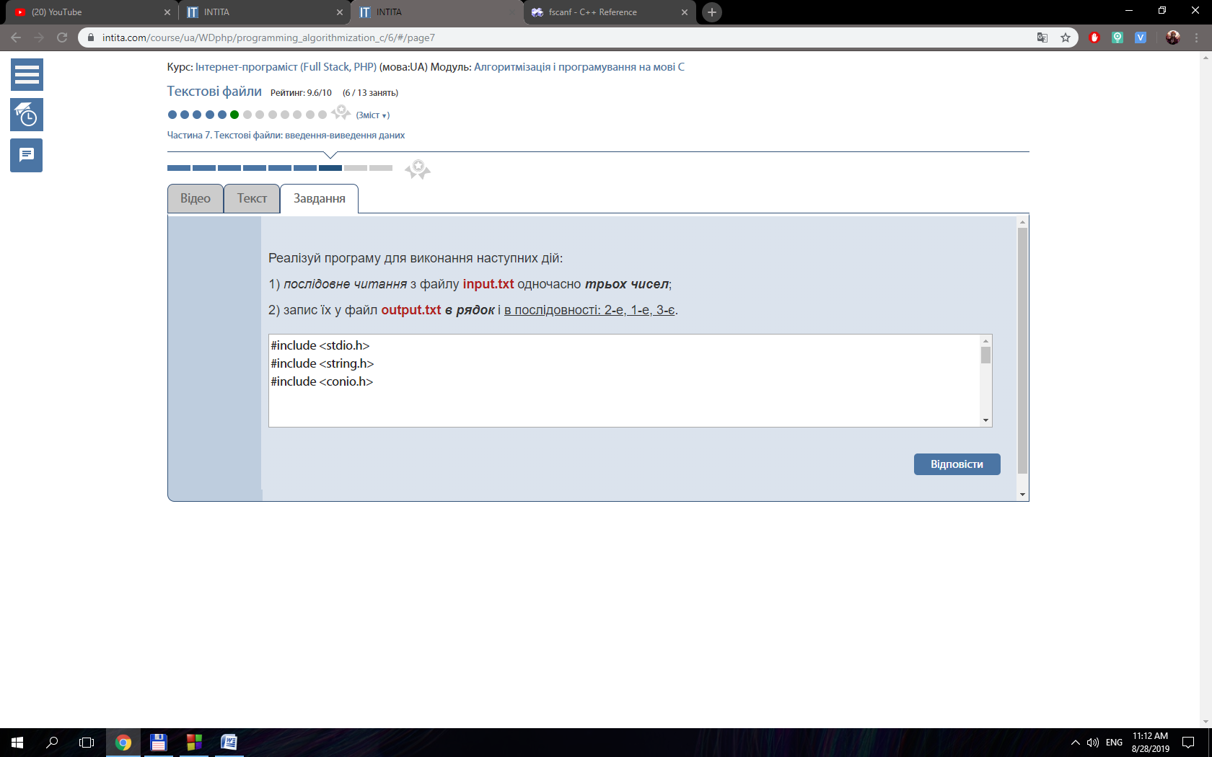

#include <stdio.h>

#include <string.h>

#include <conio.h>

int main()

{

FILE *input = fopen("input.txt", "r");

FILE *output = fopen("output.txt", "w");

char str[50];

int i;

while(fscanf(input, "%s", str) != EOF){

for (i = 0; i < 10; i++){

if (strchr (str, 48 + i) != 0){

fprintf(output, "%s ", str);

break;

}

}

}

fclose(input);

fclose(output);

getch();

return 0;

}

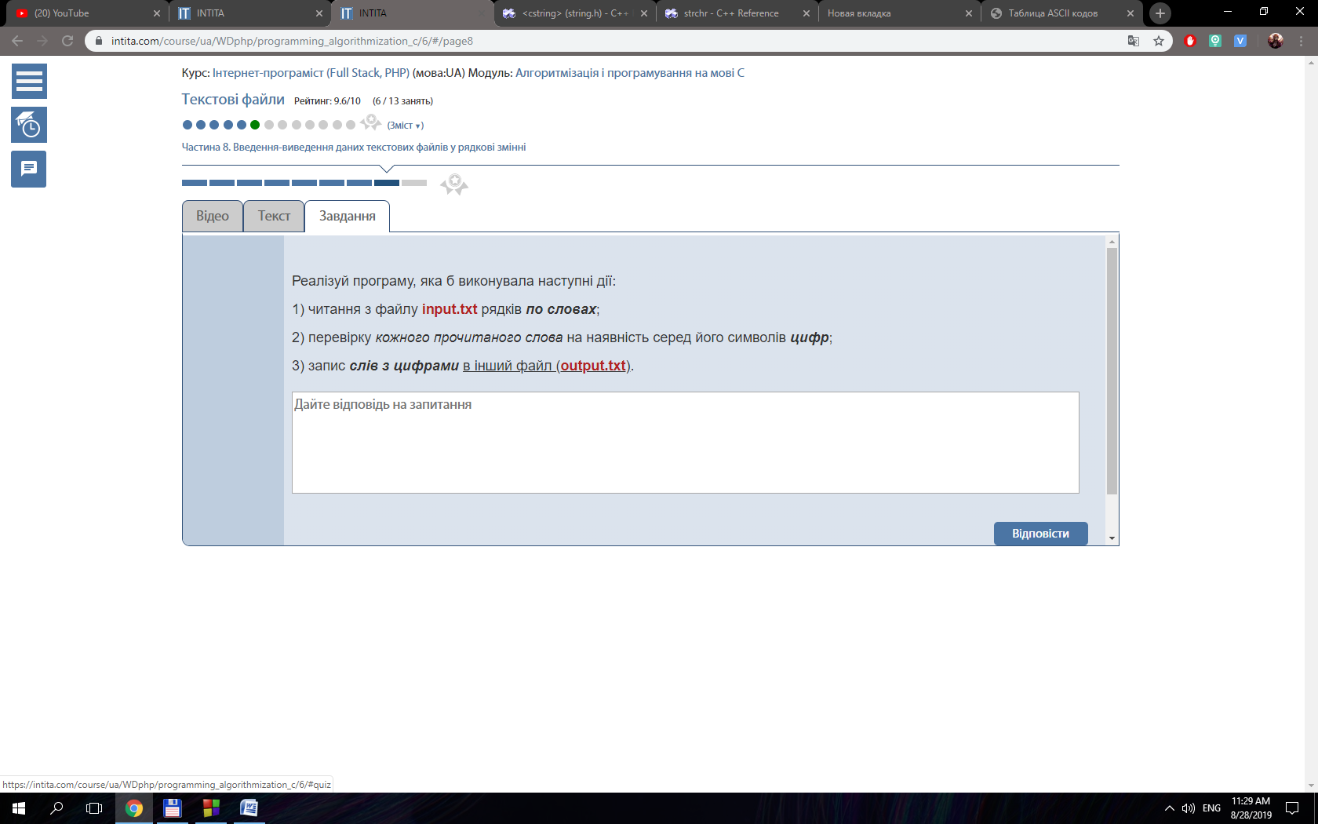

#include <stdio.h>

#include <string.h>

int main()

{

FILE *input = fopen("input.txt", "r");

FILE *validNumbers = fopen("validNumbers.txt", "w");

FILE *integers = fopen("integers.txt", "w");

float tempFloat, sumFloat = 0, lastValidNum;

int tempInt, sumInt = 0, sumIntParts = 0;

while(fscanf(input, "%f", &tempFloat) != EOF){

tempInt = tempFloat;

if (tempFloat - tempInt == 0){

fprintf(integers, "%i\n", tempInt);

sumInt += tempInt;

}else {

fprintf(validNumbers, "%g\n", tempFloat);

sumFloat += tempFloat;

sumIntParts += tempInt;

}

}

fprintf(integers, "Sum = %i\n", sumInt);

fprintf(validNumbers, "Sum = %g\n", sumFloat);

freopen("validNumbers.txt", "a",validNumbers );

freopen("validNumbers.txt", "r",input );

rewind(validNumbers);

lastValidNum = tempFloat;

fprintf(validNumbers, "Integer parts: ");

while(fscanf(input, "%f", &tempFloat) != EOF){

tempInt = tempFloat;

fprintf(validNumbers, "%i ", tempInt);

if (tempFloat == lastValidNum) break;

}

fprintf(validNumbers, "\nSum of integer parts: %i", sumIntParts);

fclose(input);

fclose(validNumbers);

fclose(integers);

return 0;

}

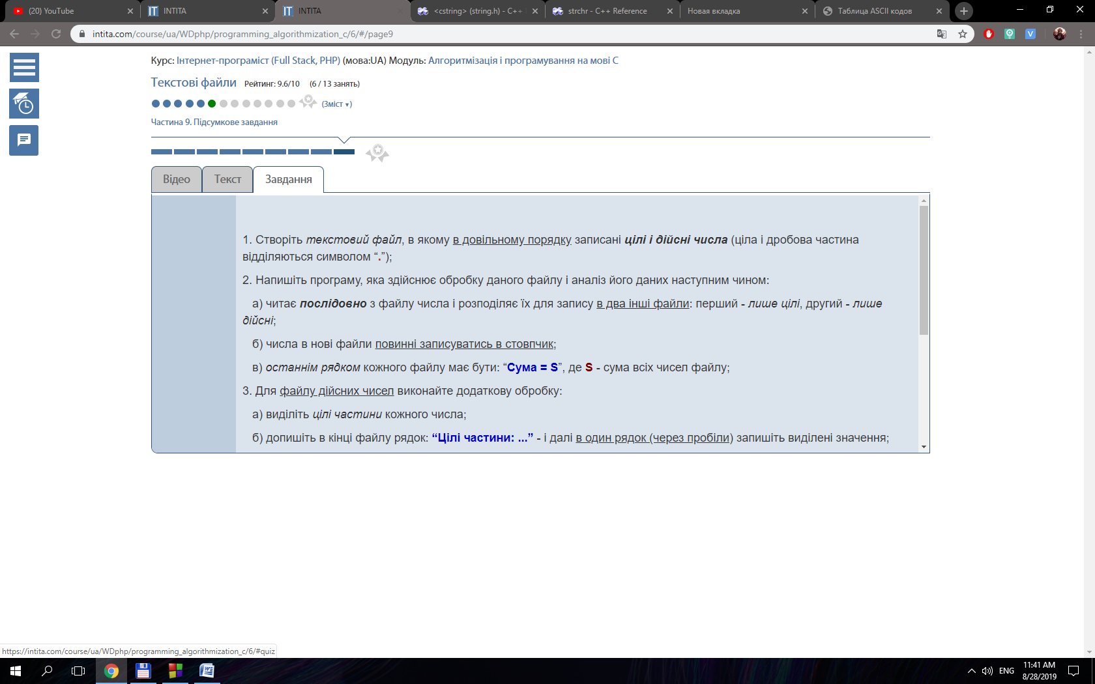

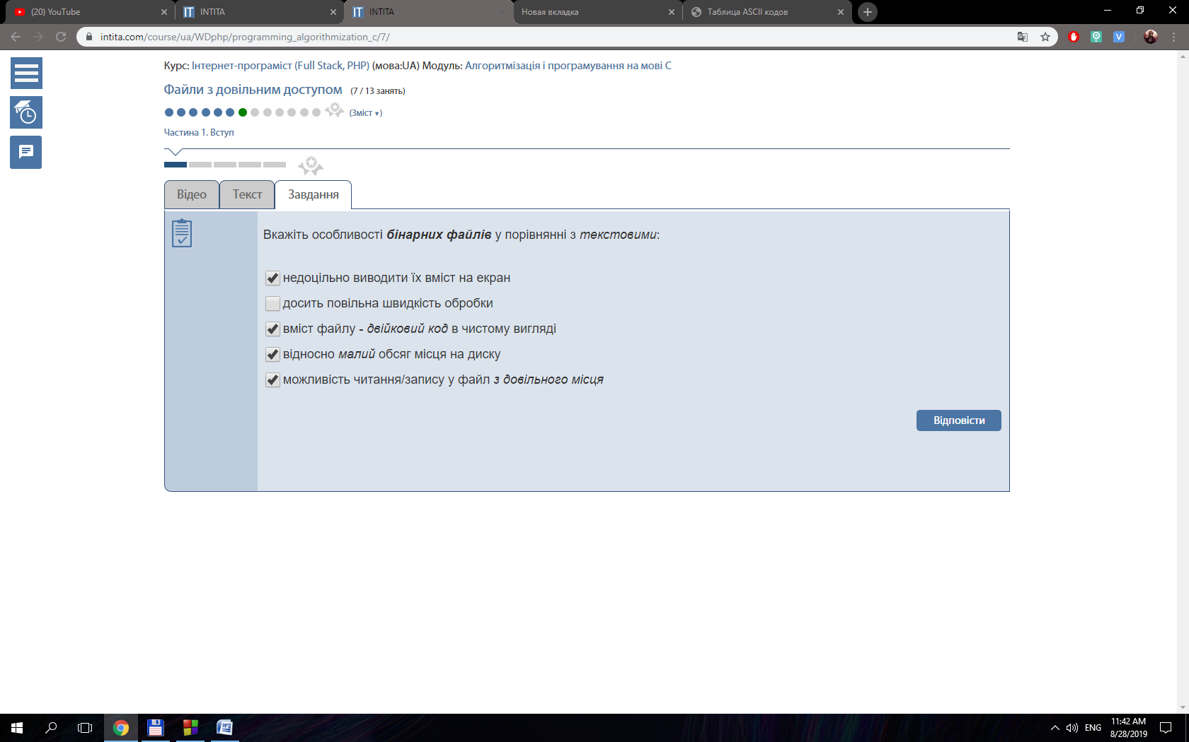

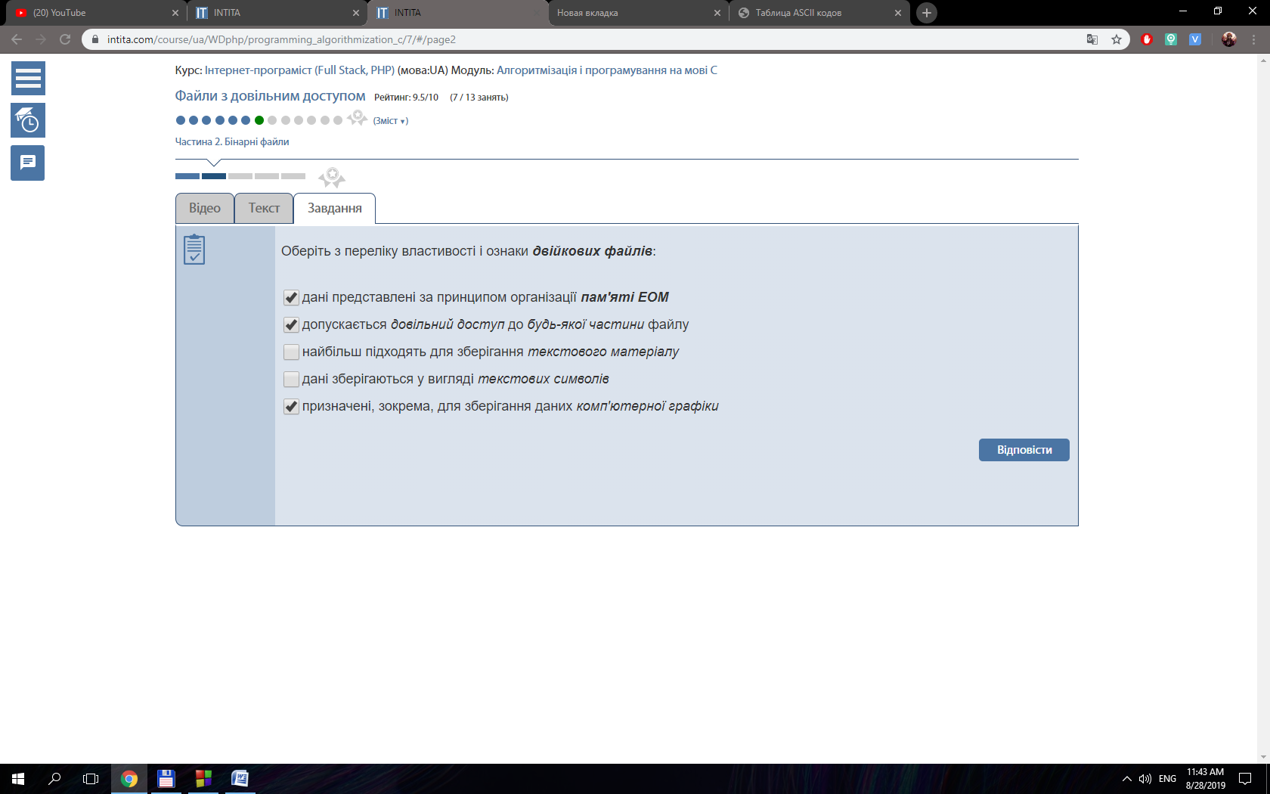

#include <stdio.h>

#include <stdlib.h>

int main()

{

FILE* fp = fopen("input.dat", "rb");

int a;

fread(&a, sizeof(int), 1, fp);

printf("1. %i\n", a);

fseek(fp, sizeof(int), SEEK_CUR);

fread(&a, sizeof(int), 1, fp);

printf("2. %i\n", a);

fseek(fp, sizeof(int), SEEK_SET);

fread(&a, sizeof(int), 1, fp);

printf("3. %i\n", a);

fseek(fp, sizeof(int), SEEK_CUR);

fread(&a, sizeof(int), 1, fp);

printf("4. %i\n", a);

fclose(fp);

return 0;

}

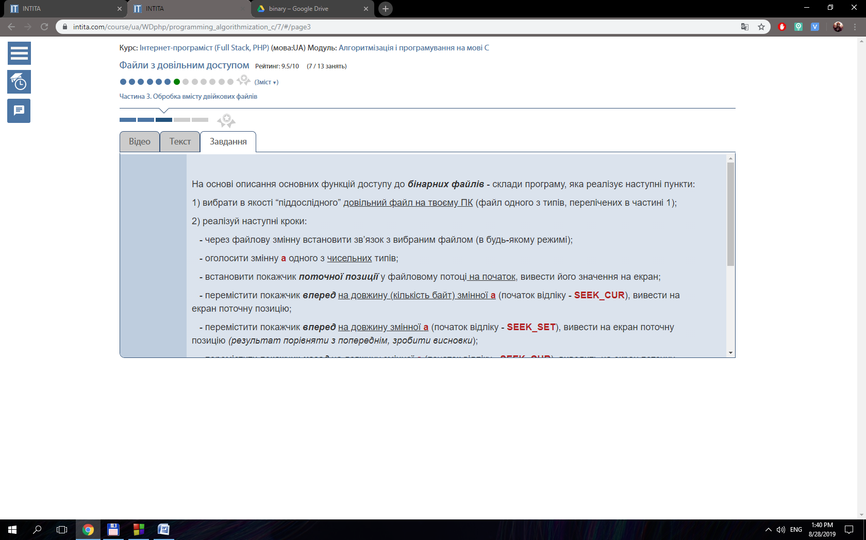

#include <stdio.h>

#include <stdlib.h>

#include <time.h>

#define N 15

#define M 16

void creatingBinaryFile ();

int main()

{

creatingBinaryFile ();

FILE* fp = fopen ( "input.dat", "rb" );

FILE* fpOutput = fopen ( "output.dat", "wb" );

int A[N] = {}, i = 0, j, B[M] = {}, temp;

if ( fread ( A, sizeof ( int ), N, fp ) >= N )

{

fread ( B, sizeof ( int ), M, fp );

if ( feof(fp)){

printf ( "Reached end of file!\n" );

} else {

printf ( "In file are there more number than space in array." );

return 0;

}

}

else

{

printf ( "Reached end of file!\n" );

}

for ( i = 0; i < N; i++ )

{

temp = A[i] + B[i];

fwrite ( &temp, sizeof ( int ), 1, fpOutput );

}

freopen ( "output.dat", "rb", fpOutput );

for ( i = 0; i < N; i++ )

{

fread(&j, sizeof(int), 1, fpOutput);

printf ( "j = %i A = %i B = %i\n", j, A[i], B[i] );

}

fclose ( fp );

fclose ( fpOutput );

return 0;

}

void creatingBinaryFile (){

srand(time(NULL));

FILE* fp = fopen("input.dat", "wb");

int arr [30], i;

for (i = 0; i < 30; i++){

arr[i] = rand() % 11;

}

fwrite(arr, sizeof(int), 30, fp);

fclose(fp);

}

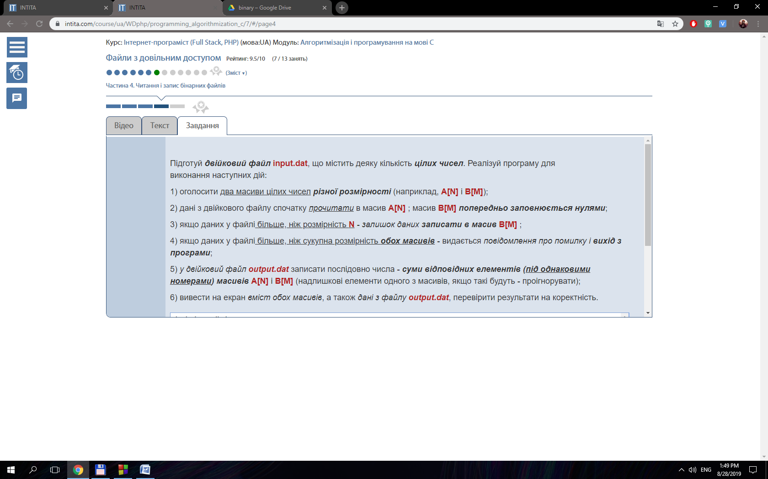

#include <math.h>

#include <stdio.h>

#include <conio.h>

int main()

{

FILE* f;

f = fopen("contacts.dat", "rb");

int length = 11, i, lengthFile;

char name [20];

char surname [20];

int telefonNumber, tempTelefonNumber1;

float age, tempAge1;

char tempName1[20] ;

char tempSurname1 [20];

// Наступний цикл призначений для введення даних, він був закоментований, щоб кожен раз не вводити всі дані заново.

// for ( i = 1 ; i < length + 1;i++ ){

// printf("Enter dates (name, surname, age, telefonNumber): ");

// scanf("%s %s %f %i", name, surname, &age, &telefonNumber);

// fflush(stdin);

// fwrite(name, sizeof(name), 1, f);

// fwrite(surname, sizeof(surname), 1, f);

// fwrite(&age, sizeof(float), 1, f);

// fwrite(&telefonNumber, sizeof(int), 1, f);

// }

for ( i = 1 ; i < length + 1; i++ )

{

fread ( name, sizeof ( name ), 1, f );

fread ( surname, sizeof ( surname ), 1, f );

fread ( &age, sizeof ( float ), 1, f );

fread ( &telefonNumber, sizeof ( int ), 1, f );

printf ( "%s %s %f %i\n", name, surname, age, telefonNumber );

}

printf("\n");

lengthFile = sizeof(name) + sizeof(surname)+ sizeof(int) + sizeof(float);

freopen("contacts.dat", "rb+", f);

for ( i = 0 ; i < 11/2; i++ ){

fseek(f, lengthFile * i, SEEK_SET);

fread(name, sizeof(name), 1, f);

fread(surname, sizeof(surname), 1, f);

fread(&age, sizeof(float), 1, f);

fread(&telefonNumber, sizeof(int), 1, f);

fseek(f, lengthFile * (11 - i - 1), SEEK_SET);

fread(tempName1, sizeof(name), 1, f);

fread(tempSurname1, sizeof(surname), 1, f);

fread(&tempAge1, sizeof(float), 1, f);

fread(&tempTelefonNumber1, sizeof(int), 1, f);

fseek(f, lengthFile * (11 - i - 1), SEEK_SET);

fwrite(name, sizeof(name), 1, f);

fwrite(surname, sizeof(surname), 1, f);

fwrite(&age, sizeof(float), 1, f);

fwrite(&telefonNumber, sizeof(int), 1, f);

fseek(f, lengthFile * i, SEEK_SET);

fwrite(tempName1, sizeof(name), 1, f);

fwrite(tempSurname1, sizeof(surname), 1, f);

fwrite(&tempAge1, sizeof(float), 1, f);

fwrite(&tempTelefonNumber1, sizeof(int), 1, f);

}

rewind (f);

for ( i = 1 ; i < length + 1; i++ )

{

fread ( name, sizeof ( name ), 1, f );

fread ( surname, sizeof ( surname ), 1, f );

fread ( &age, sizeof ( float ), 1, f );

fread ( &telefonNumber, sizeof ( int ), 1, f );

printf ( "%s %s %f %i\n", name, surname, age, telefonNumber );

}

fclose ( f );

getch();

return 0;

}

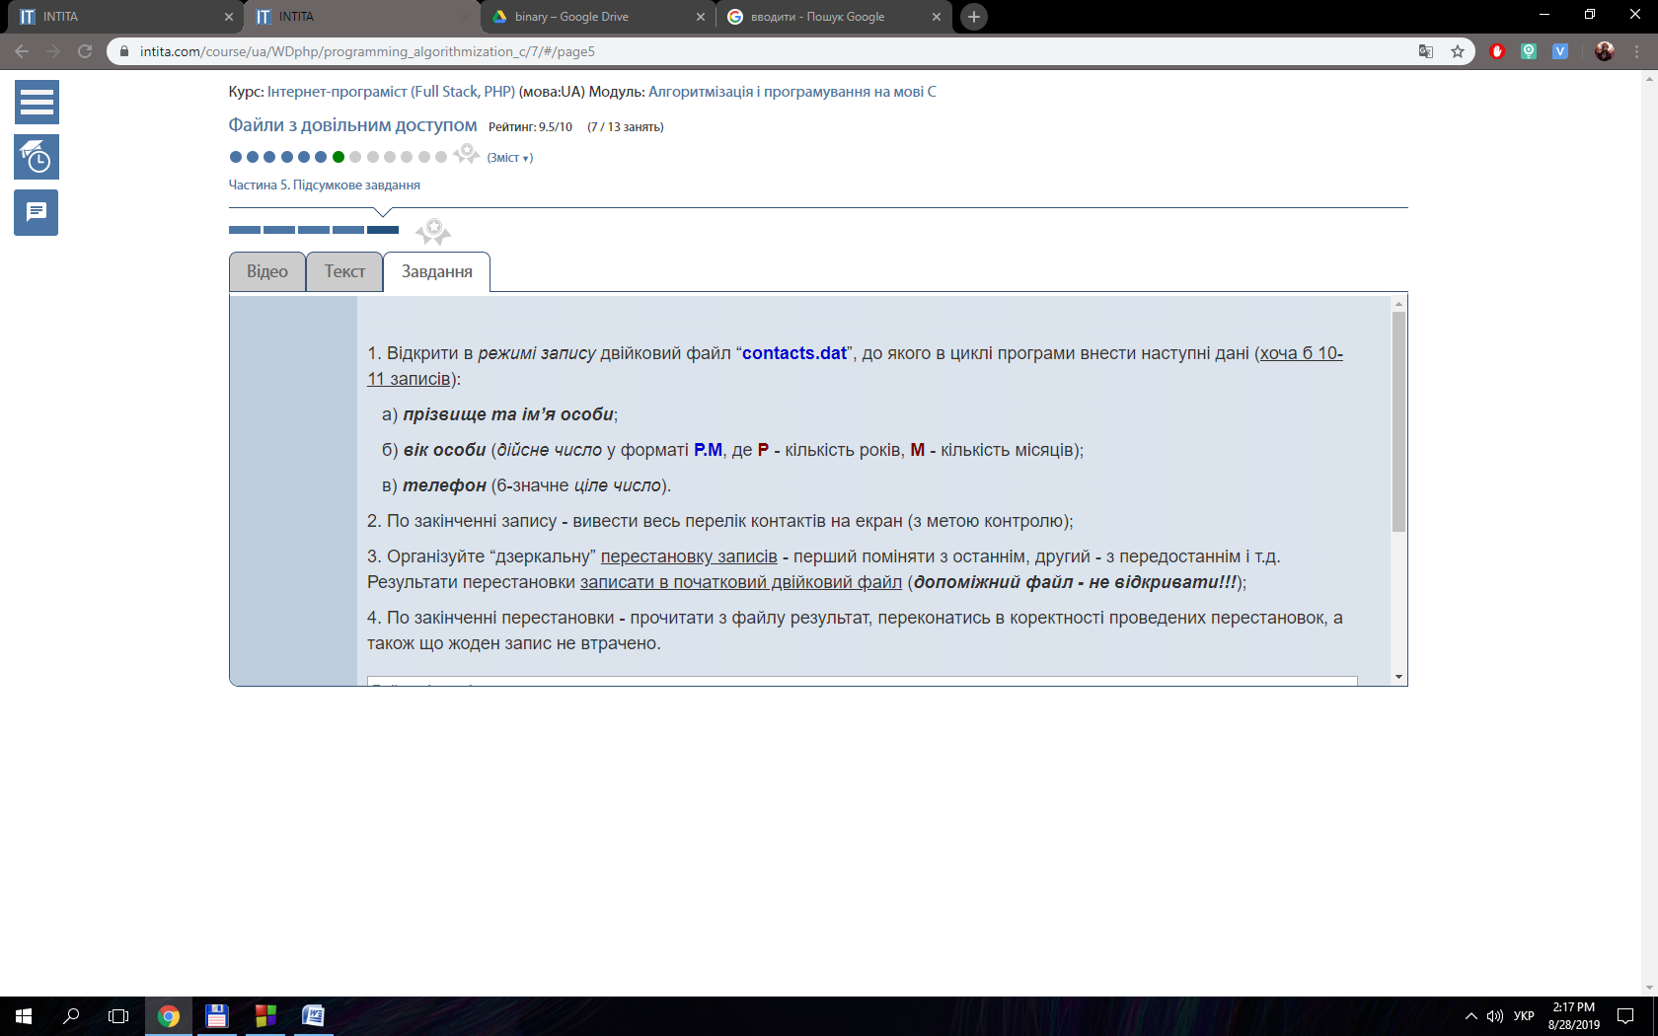

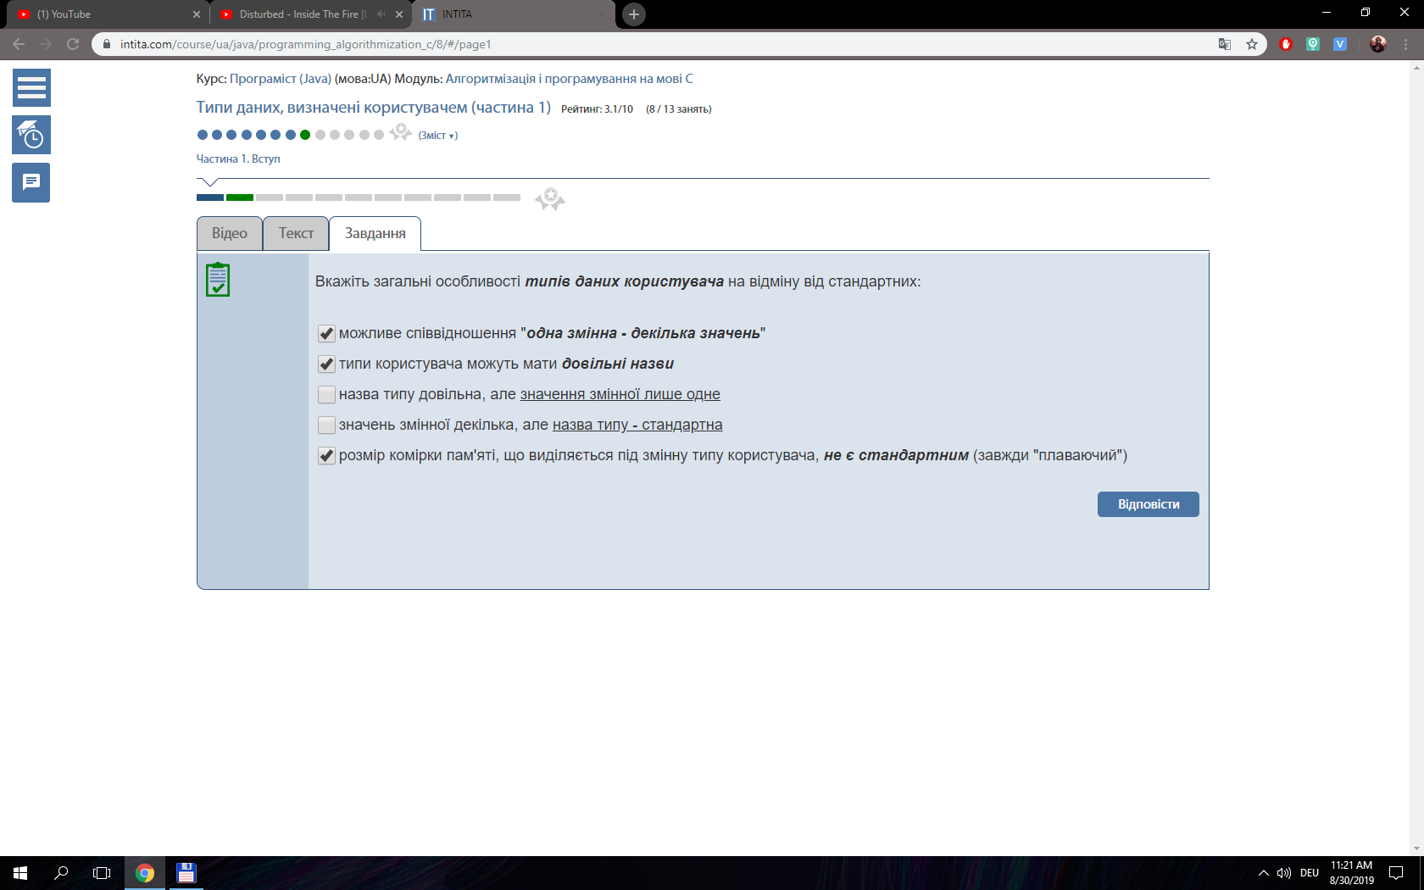

{

bool num;

if (f == 0){

num = 0;

return "FALSE";

}

num = 1;

return "TRUE";

}

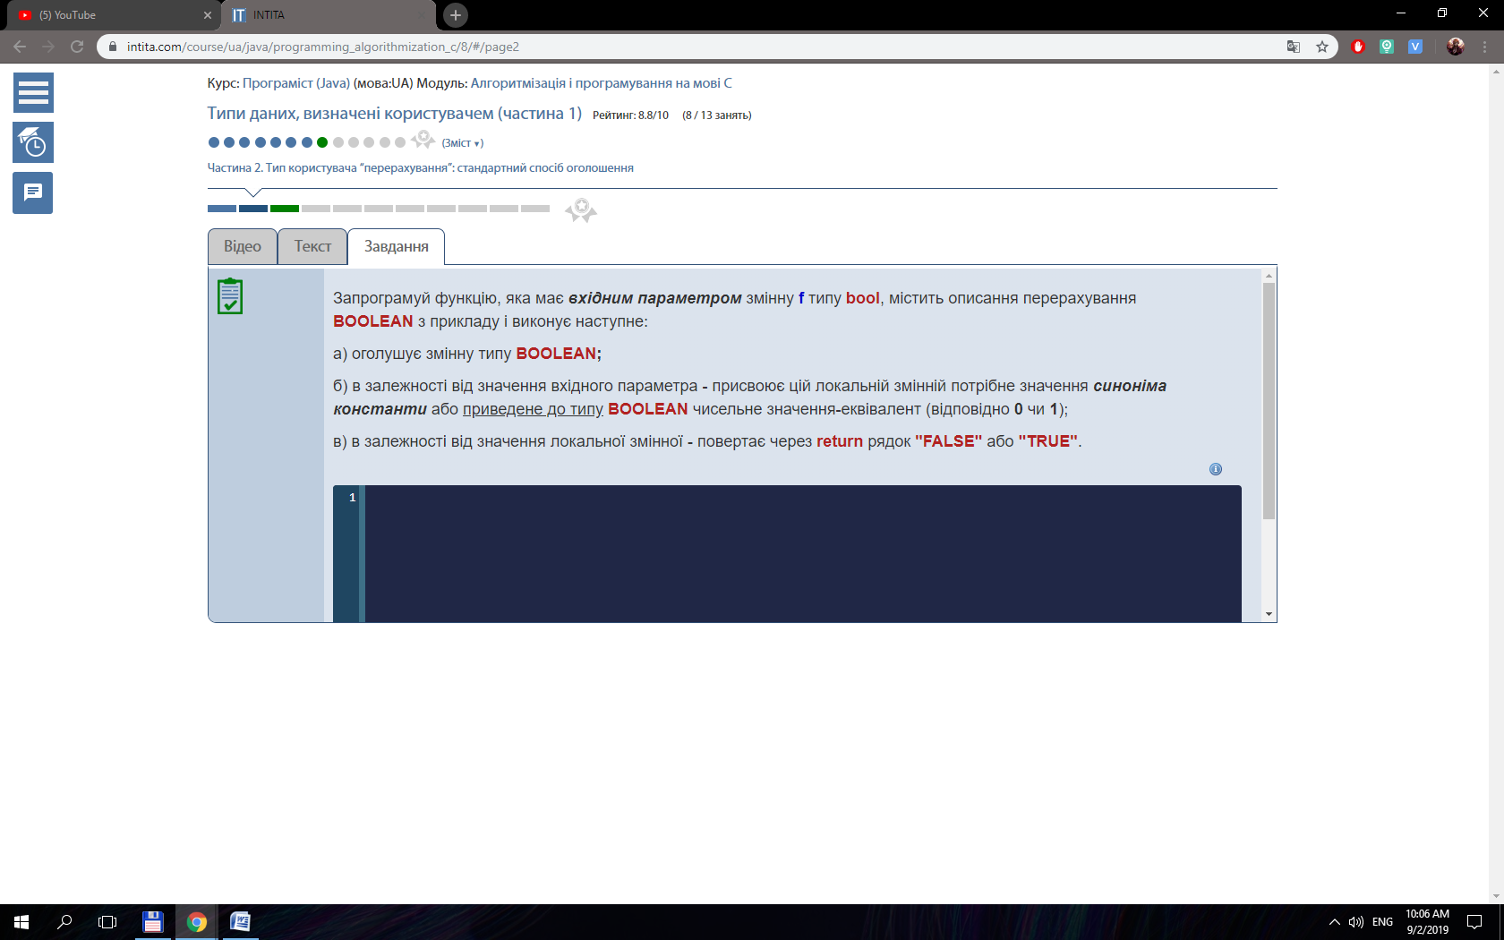

{  
place [0] = 1;   
place [1] = 3;  
place [2] = 5;  
place [3] = 7;  
place [4] = 8;  
place [5] = 10;  
place [6] = 11;  
return place;  
}

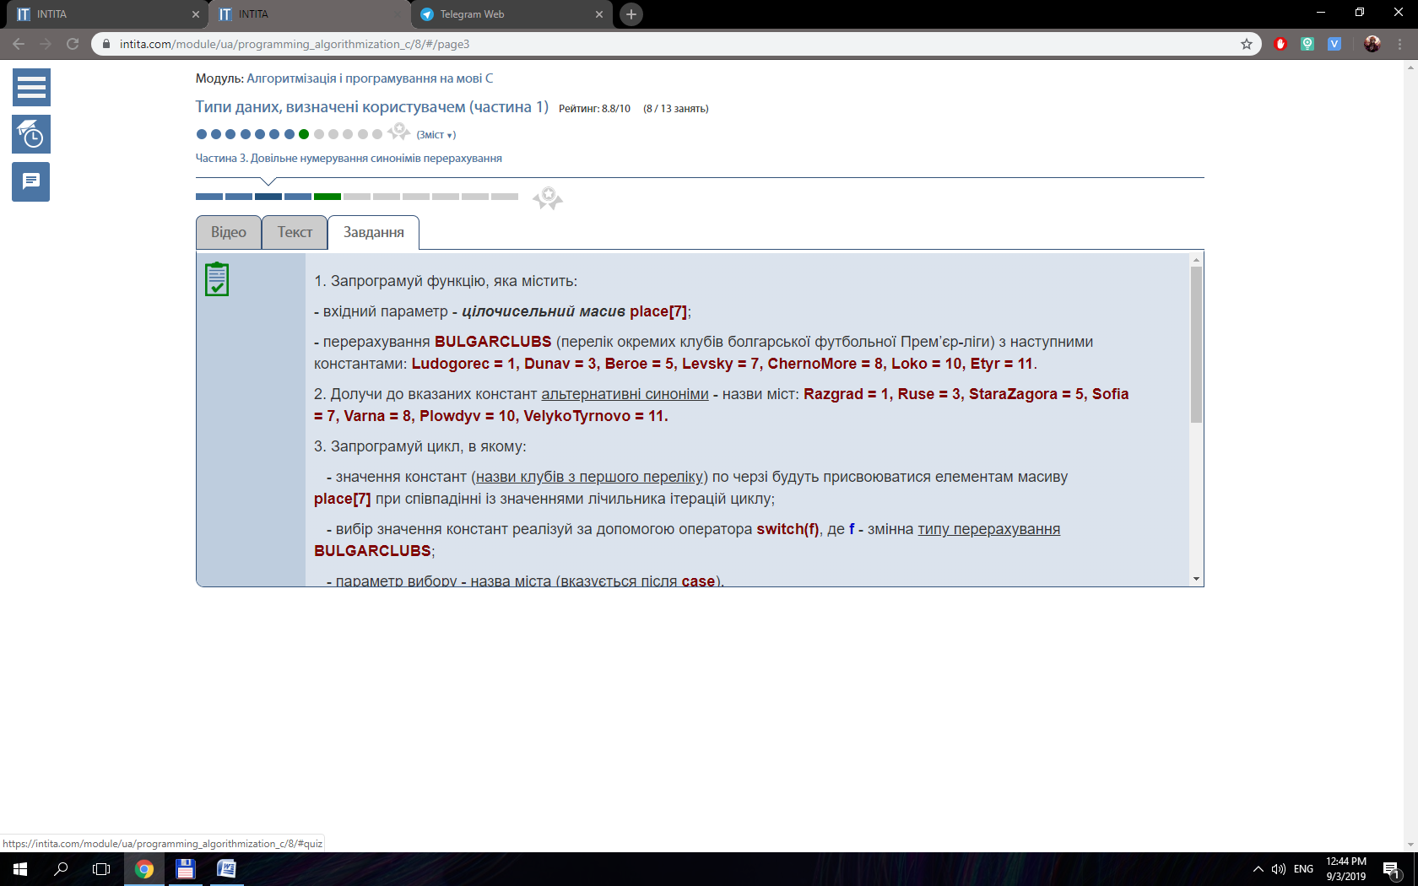

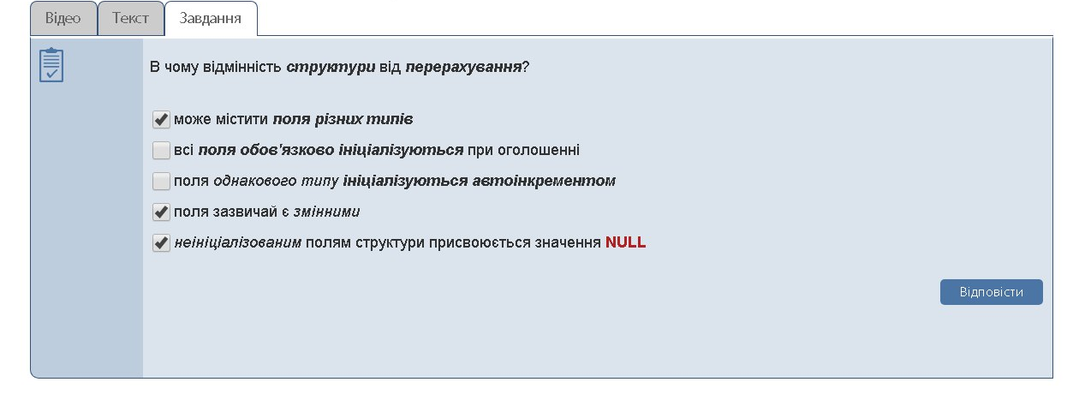

{

towns[0] = "Razgrad";

towns[1] = "Ruse";

towns[2] = "StaraZagora";

towns[3] = "Sofia";

towns[4] = "Varna";

towns[5] = "Plowdyv";

towns[6] = "VelykoTyrnovo";

return towns;

}

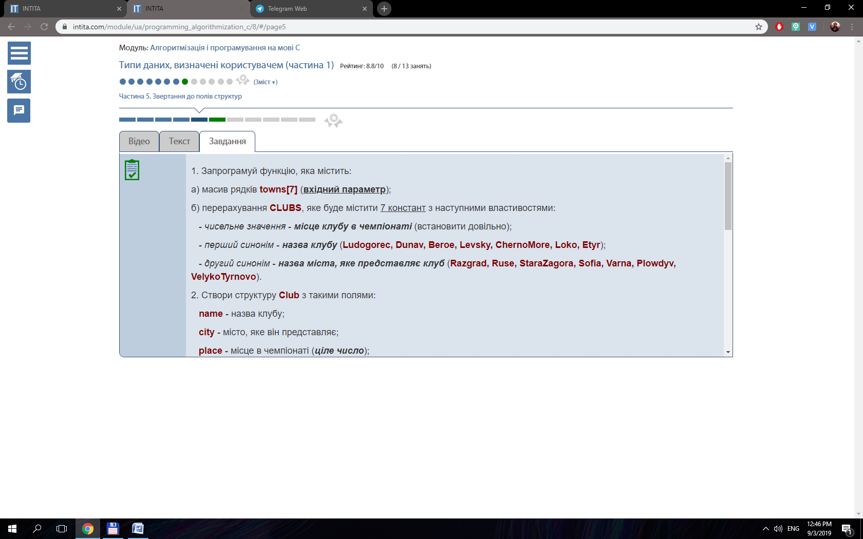

#include <stdio.h>

#include <conio.h>

typedef struct

{

char name [20];

char city [20];

int place;

} Club;

int main()

{

Club A[7];

int i, j;

for ( i = 0; i < 7; i++ )

{

printf ( "Input the name of %i club: ", i + 1 );

scanf ( "%s", A[i].name );

printf ( "Input the city of %i club: ", i + 1 );

scanf ( "%s", A[i].city );

printf ( "Input place in the championship of %i club: ", i + 1 );

scanf ( "%i", &A[i].place );

printf ( "Club %i: %s from %s took the place %i\n", i + 1, A[i].name, A[i].city, A[i].place );

}

for ( i = 1; i <= 7; i++ )

for ( j = 0; j < 7; j++ )

if ( A[j].place == i )

{

printf ( "Place %i took club %s from %s\n", i + 1, A[j].name, A[j].city );

}

getch();

return 0;

}

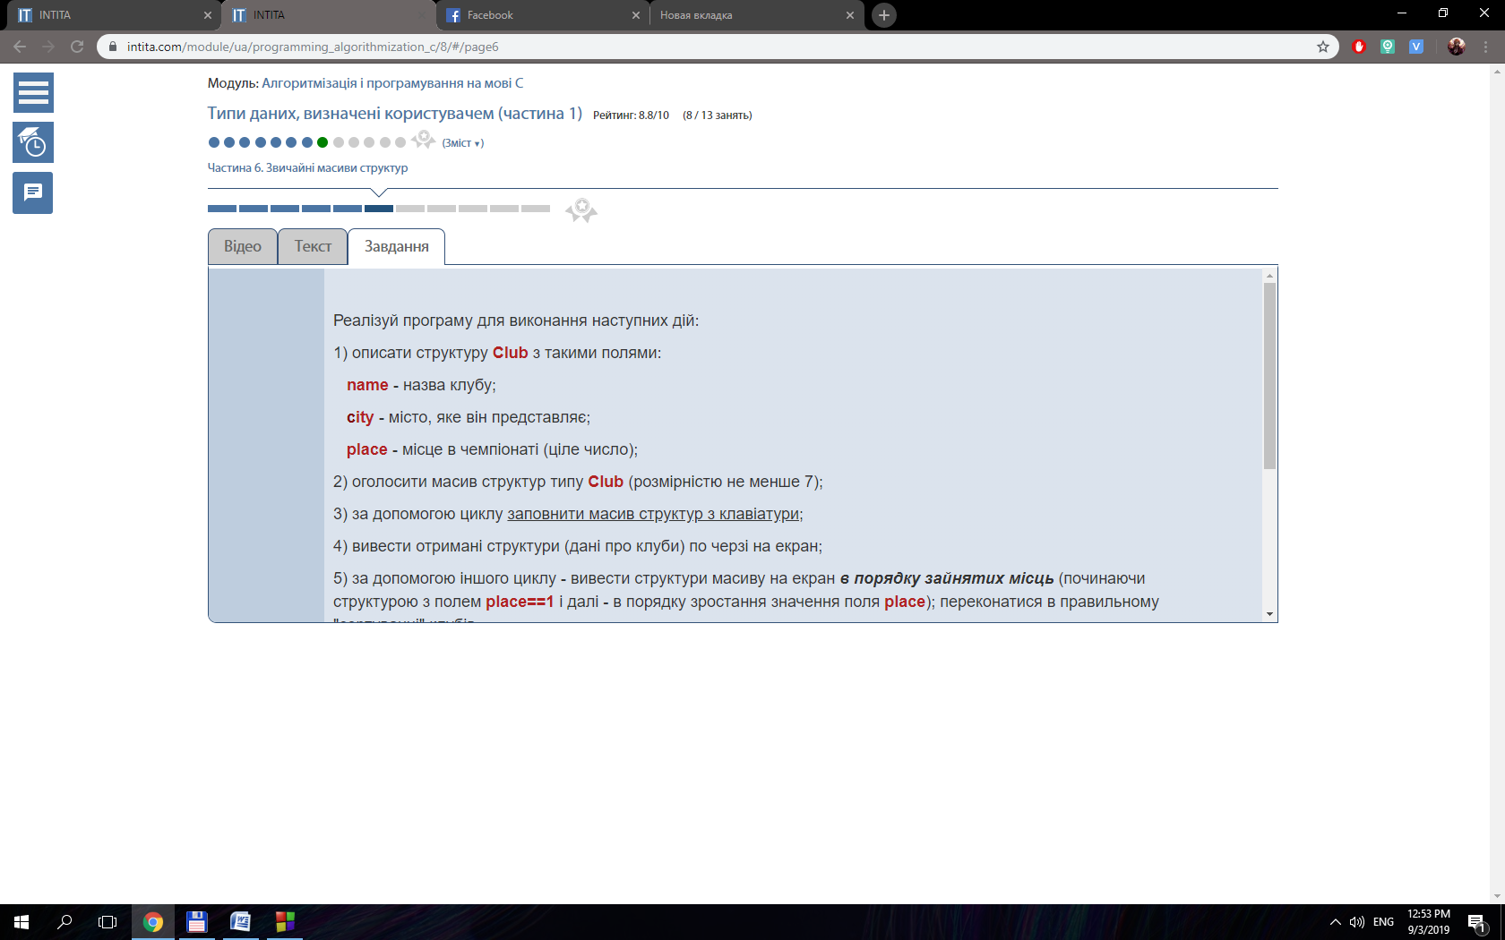

{

int array[11];

int i;

for ( i = 1; i < 11; i++){

array[i] = places[i-1];

}

array[0] = 8;

for ( i = 0; i < 10; i++){

places [i] = array[i];

}

return places;

}

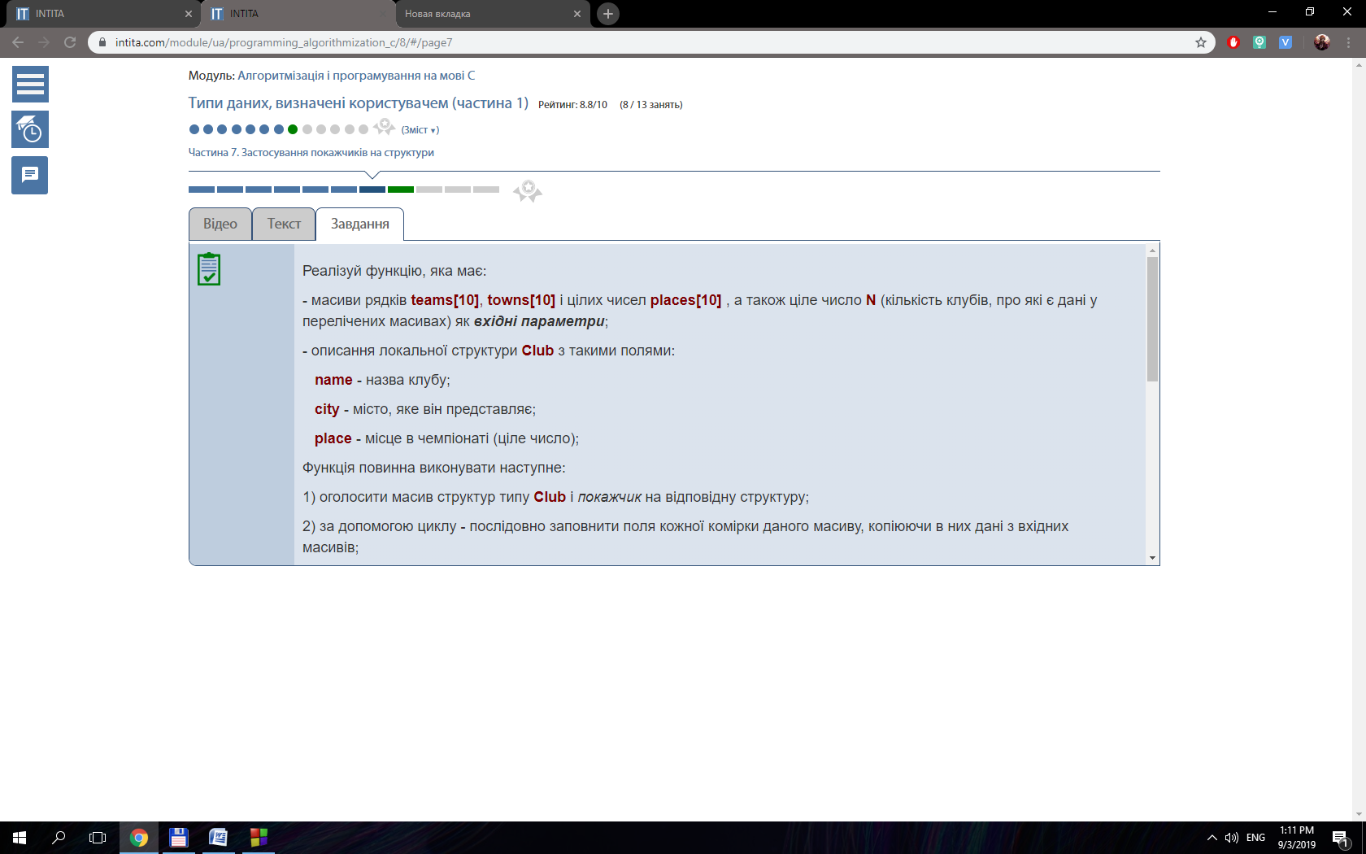

#include <stdio.h>

#include <conio.h>

typedef struct

{

char name [20];

char city [20];

int place;

} Club;

int main()

{

Club var;

int i;

FILE *team2;

FILE *team = fopen ( "teams.dat", "ab" );

for ( i = 0; i < 7; i++ )

{

printf ( "Enter name, city, place: " );

scanf ( "%s %s %i", var.name, var.city, &var.place );

fwrite ( &var, sizeof ( int ), 11, team );

}

freopen ( "teams.dat", "rb", team );

team2 = fopen ( "teams2.dat", "wb" );

for ( i = 0; i < 3; i++ )

{

fread ( &var, sizeof ( int ), 11, team );

fwrite ( &var, sizeof ( int ), 11, team2 );

}

freopen ( "teams2.dat", "rb", team2 );

for ( i = 0; i < 3; i++ )

{

fread ( &var, sizeof ( int ), 11, team2 );

printf ( "Team = %s; city = %s; place = %i\n", var.name, var.city, var.place );

}

fclose ( team );

fclose ( team2 );

getch();

return 0;

}

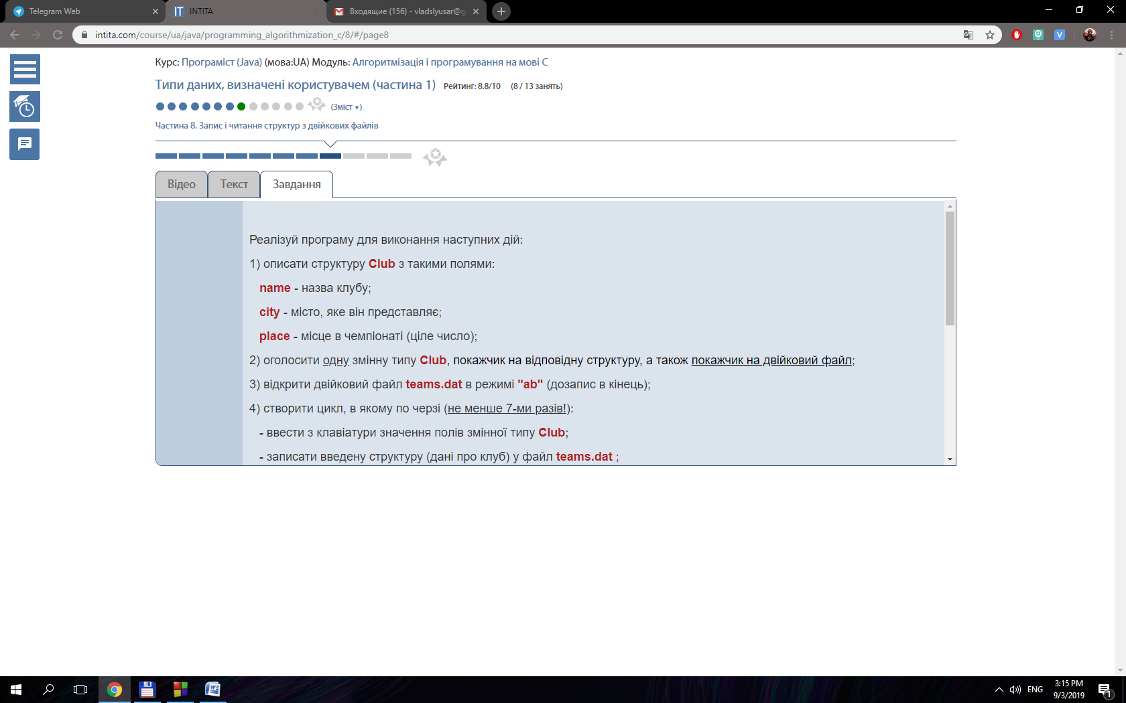

#include <stdio.h>

#include <conio.h>

#include <string.h>

typedef struct

{

char name [20];

char city [20];

int place;

} Club;

int main()

{

Club club1, club2, *pClub1 = &club1, *pClub2 = &club2;

int i;

FILE *team = fopen ( "teams.dat", "ab" );

char choice;

printf ( "Enter method of copy (1 - pointer; 2 - memcpy; 3 - reassignment) :\n" );

do

{

choice = getch();

}

while ( choice < '1' || choice > '3' );

switch ( choice )

{

case '1':

{

for ( i = 0; i < 7; i++ )

{

printf ( "Enter name, city, place: " );

scanf ( "%s %s %i", club1.name, club1.city, &club1.place );

strcpy ( pClub2 ->name, pClub1 ->name );

strcpy ( pClub2 ->city, pClub1 ->city );

pClub2 ->place = pClub1 ->place;

fwrite ( &club2, sizeof ( int ), 11, team );

}

break;

}

case '2':

{

for ( i = 0; i < 7; i++ )

{

printf ( "Enter name, city, place: " );

scanf ( "%s %s %i", club1.name, club1.city, &club1.place );

memcpy(pClub2, pClub1, 44);

fwrite ( &club2, sizeof ( int ), 11, team );

}

break;

}

case '3':

{

for ( i = 0; i < 7; i++ )

{

printf ( "Enter name, city, place: " );

scanf ( "%s %s %i", club1.name, club1.city, &club1.place );

club2 = club1;

fwrite ( &club2, sizeof ( int ), 11, team );

}

break;

}

default:

break;

}

freopen ( "teams.dat", "rb", team );

for ( i = 0; i < 7; i++ )

{

fread ( &club1, sizeof ( int ), 11, team );

printf ( "Team = %s; city = %s; place = %i\n", club1.name, club1.city, club1.place );

}

fclose ( team );

getch();

return 0;

}

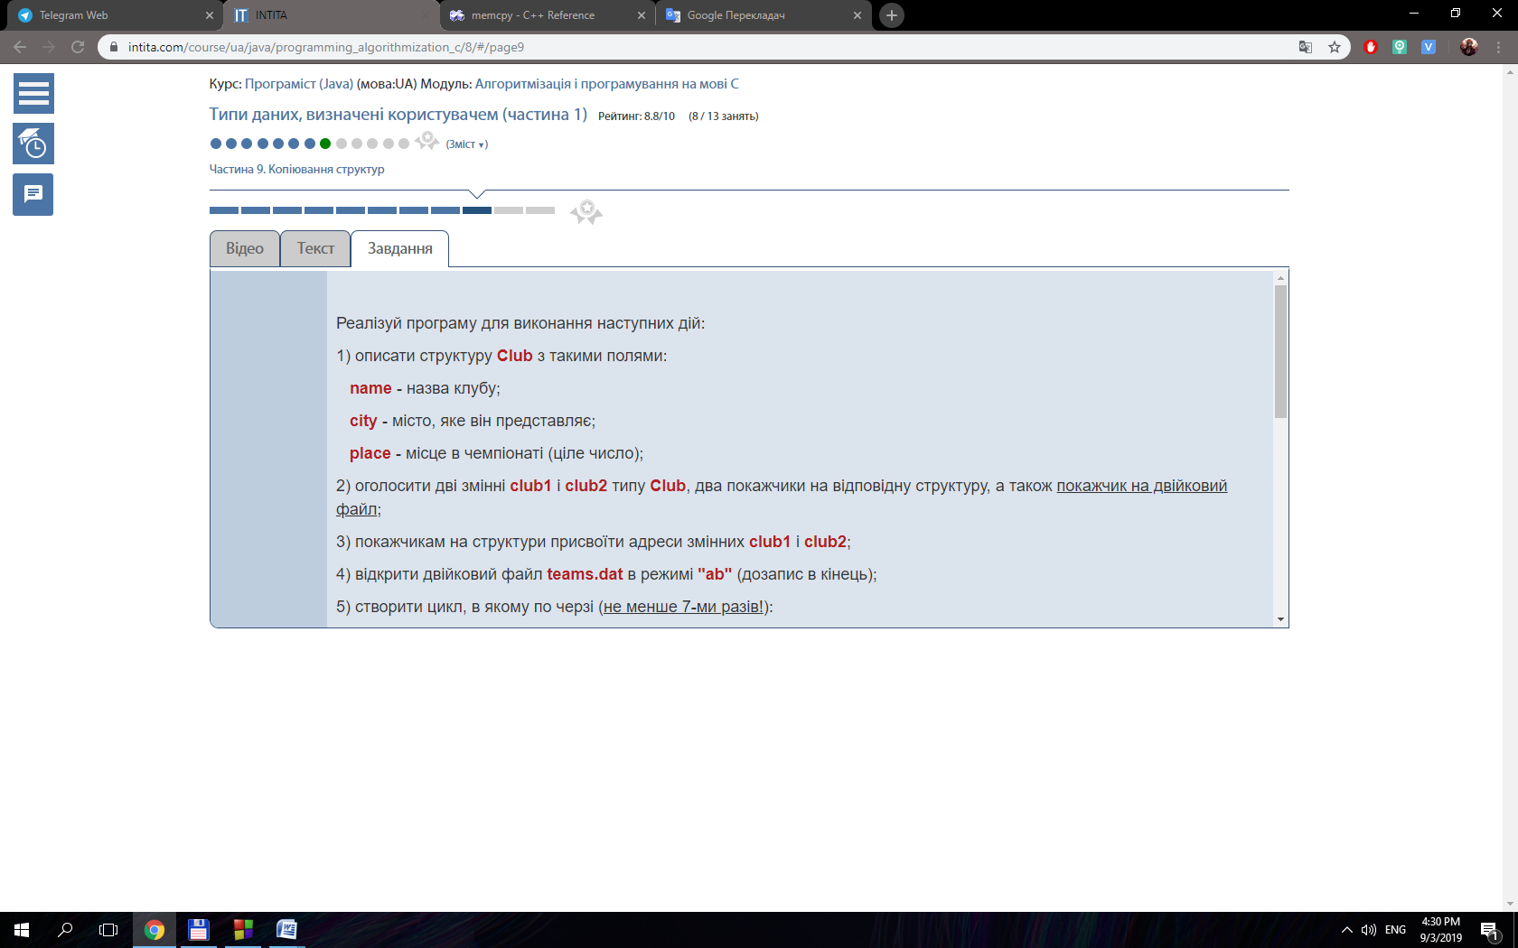

{

string *names;

names = (string*) calloc (sizeof(char), N);

int i, j;

for (i=0; i<N; i++){

for (j=0; j<N; j++){

if (places [j] == i+1){

names [i] = teams[j];

}

}

}

return names;

}

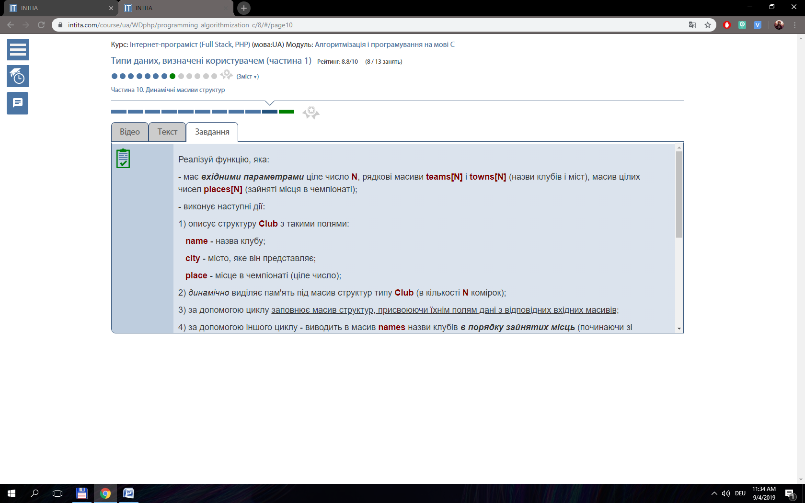

#include <stdio.h>

#include <conio.h>

#include <string.h>

#include <stdlib.h>

typedef struct

{

char name [20];

char city [20];

int place;

} Club;

void datCopy ( Club *teams, int n );

void datSort ( Club *teams, int n );

void copyToFile ( Club *teams, int n );

void checkBinFile (int n);

int main()

{

int i = 0, n;

do

{

printf ( "Enter number of clubs for reading: " );

scanf ( "%i", &n );

}

while ( n < 1 || n > 10 );

Club *teams = ( Club* ) calloc ( 44, n );

datCopy ( teams, n );

datSort ( teams, n );

copyToFile ( teams, n );

checkBinFile ( n);

free ( teams );

getch();

return 0;

}

void datCopy ( Club *teams, int n )

{

int i = 0;

FILE *input = fopen ( "input.txt", "r" );

while ( fscanf ( input, "%s %s %i", & ( teams + i )->name, & ( teams + i )->city, & ( teams + i )->place ) != EOF && i < n )

{

i++;

}

fclose ( input );

}

void datSort ( Club *teams, int n )

{

int i, j, max = 0;

Club temp;

for ( i = 0; i < n; i++ )

{

max = i;

for ( j = 0 + i; j < n; j++ )

{

if ( ( teams + j )->place > ( teams + max )->place )

{

max = j;

}

}

temp = * ( teams + max );

* ( teams + max ) = * ( teams + i );

* ( teams + i ) = temp;

}

for (i = 0; i < n; i ++){

printf("%s %s %i\n", ( teams + i )->name, ( teams + i )->city, ( teams + i )->place);

}

}

void copyToFile ( Club *teams, int n )

{

FILE *output = fopen ( "output.dat", "wb" );

int i;

for ( i = 0; i < n; i++ )

{

fwrite ( ( teams + i ), sizeof ( int ), 11, output );

}

fclose ( output );

}

void checkBinFile (int n)

{

int n_club;

Club temp;

FILE *read = fopen ( "output.dat", "rb" );

do

{

printf ( "Enter number of club: " );

scanf ( "%i", &n_club );

}

while ( n_club < 1 || n_club > n );

fseek ( read, 44 * ( n_club - 1 ), SEEK_SET );

fread ( &temp, sizeof ( int ), 11, read );

printf ( "Result: team - %s; town - %s; place - %i", temp.name, temp.city, temp.place );

fclose ( read );

}

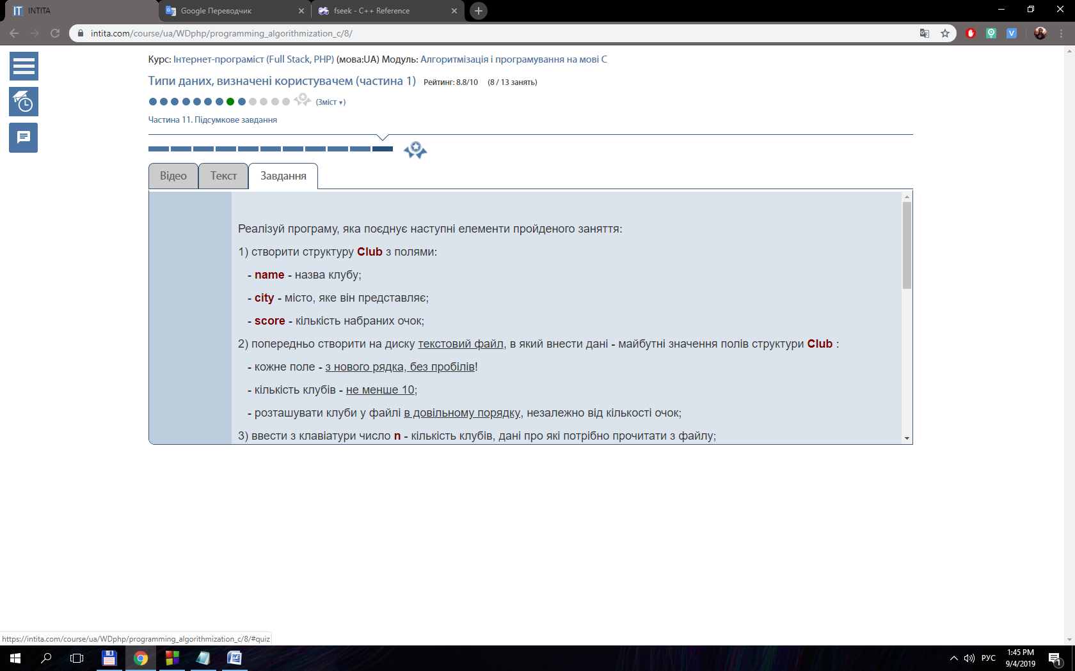

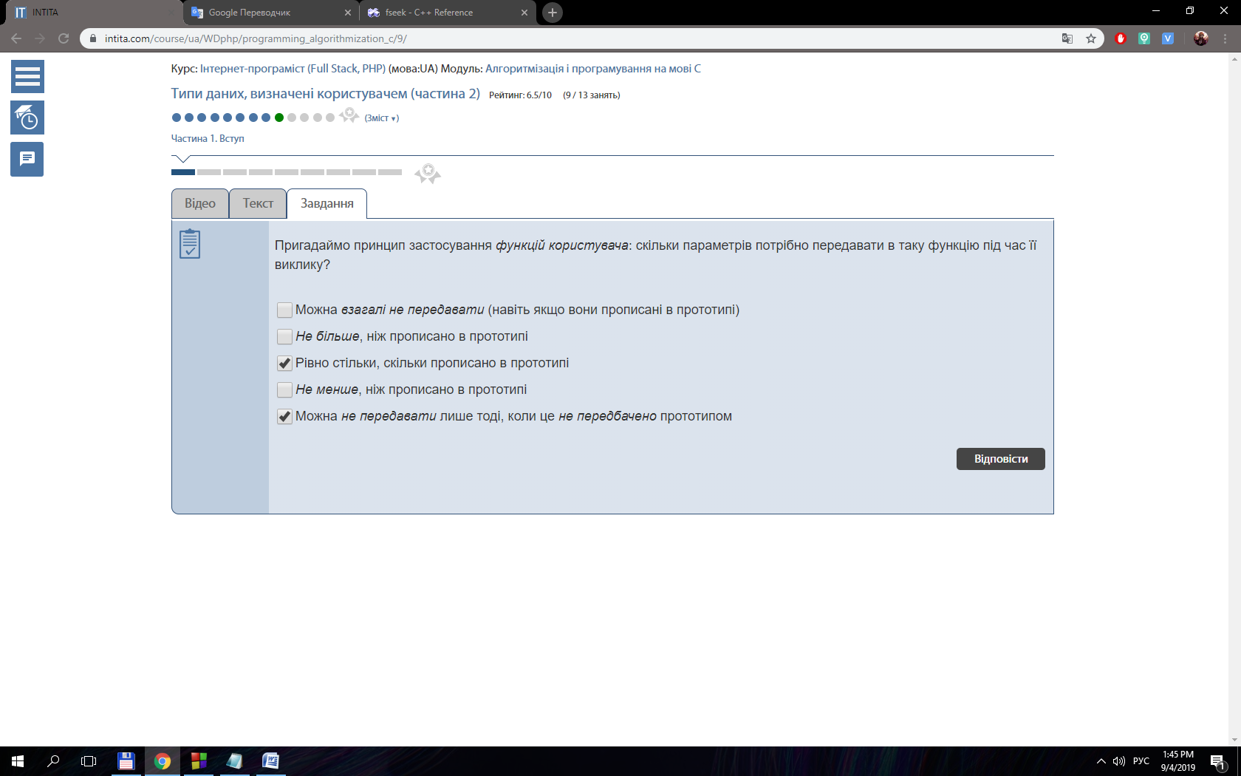

#include <stdio.h>

#include <stdlib.h>

#include <conio.h>

enum Restyle { PLACE, SCORE };

typedef union

{

int place;

int score;

} Results ;

typedef struct

{

char name [20];

char city [20];

enum Restyle info;

Results results;

} Club;

int main()

{

Club *clubs;

int numberOfClubs, i;

printf ( "Enter number of clubs: " );

scanf ( "%i", &numberOfClubs );

clubs = ( Club * ) calloc ( sizeof ( Club ), numberOfClubs );

do

{

printf ( "Enter the value of info: " );

scanf ( "%i", &clubs->info );

}

while ( clubs->info < 0 || clubs->info > 1 );

switch ( clubs->info )

{

case ( PLACE ) :

{

for ( i = 0; i < numberOfClubs; i++ )

{

printf ( "Enter place of team %i: ", i + 1 );

scanf ( "%i", & ( clubs + i ) ->results.place );

}

break;

}

case ( SCORE ) :

{

for ( i = 0; i < numberOfClubs; i++ )

{

printf ( "Enter score of team %i: ", i + 1 );

scanf ( "%i", & ( clubs + i ) ->results.score );

}

break;

}

default:

{

break;

}

}

for ( i = 0; i < numberOfClubs; i++ )

{

printf ( "Enter name of club and town: " );

scanf ( "%s %s", ( clubs + i )->name, ( clubs + i )->city );

}

for ( i = 0; i < numberOfClubs; i++ )

{

printf ( "%s %s %i\n", ( clubs + i )->name, ( clubs + i )->city, ( clubs + i ) ->results.score );

}

getch();

return 0;

}

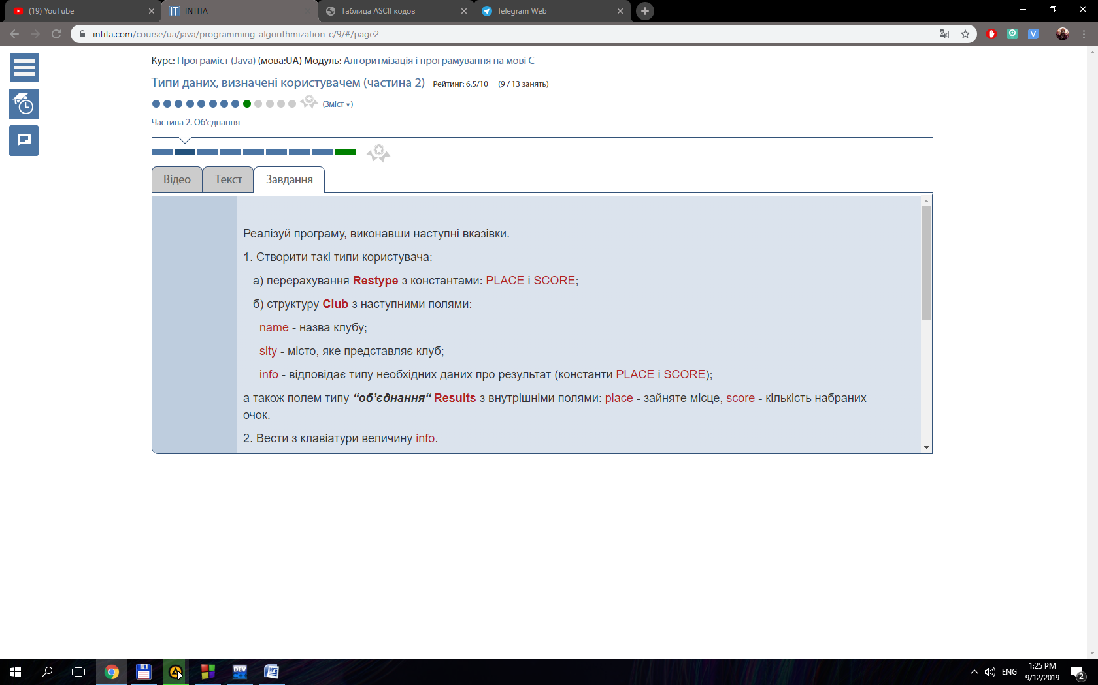

#include <stdio.h>

#include <stdlib.h>

#include <conio.h>

typedef struct {

char name [20];

char city [20];

int place;

int score;

} Club;

typedef Club ClubNum;

typedef Club* ClubPoint;

int main()

{

ClubNum clubArray [5];

int i;

for (i = 0; i < 5; i++){

printf("Enter date for team %i: ", i + 1);

scanf("%s %s %i %i", (clubArray + i)->name, (clubArray + i)->city, &(clubArray + i)->place, &(clubArray + i)->score);

}

ClubPoint clubArr = clubArray;

for (i = 0; i < 5; i++){

printf("%s %s %i %i\n", (clubArr + i)->name, (clubArr + i)->city, (clubArr + i)->place, (clubArr + i)->score);

}

getch();

return 0;

}

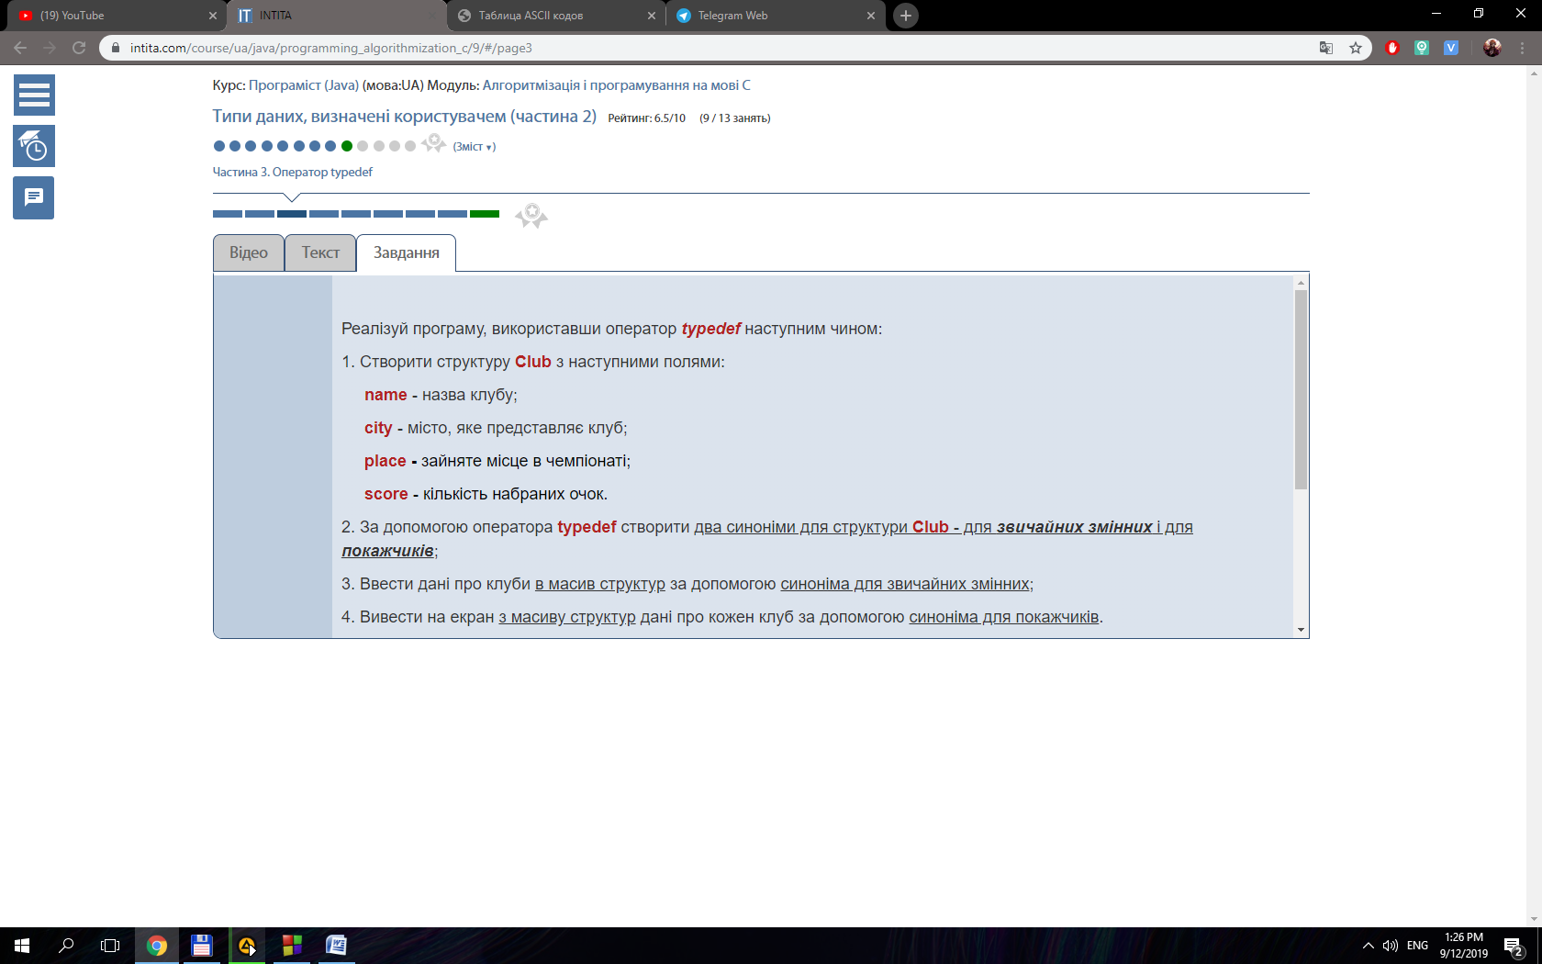

#include <stdio.h>

#include <stdlib.h>

#include <conio.h>

typedef struct {

char name [20];

char city [20];

int place;

int score;

} Club;

int main()

{

Club *teams;

int n;

do{

printf("Enter number of clubs (max 10): ");

scanf("%i", &n);

}while(n < 1 || n > 10);

teams = (Club*) malloc(sizeof(Club)* n);

int i;

for (i = 0; i < n; i++){

printf("Enter date for team %i(name, town, place, score): ", i + 1);

scanf("%s %s %i %i", (teams + i)->name, (teams + i)->city, &(teams + i)->place, &(teams + i)->score );

}

for (i = 0; i < n; i++){

printf("%s %s %i %i\n", (teams + i)->name, (teams + i)->city, (teams + i)->place, (teams + i)->score);

}

free(teams);

getch();

return 0;

}

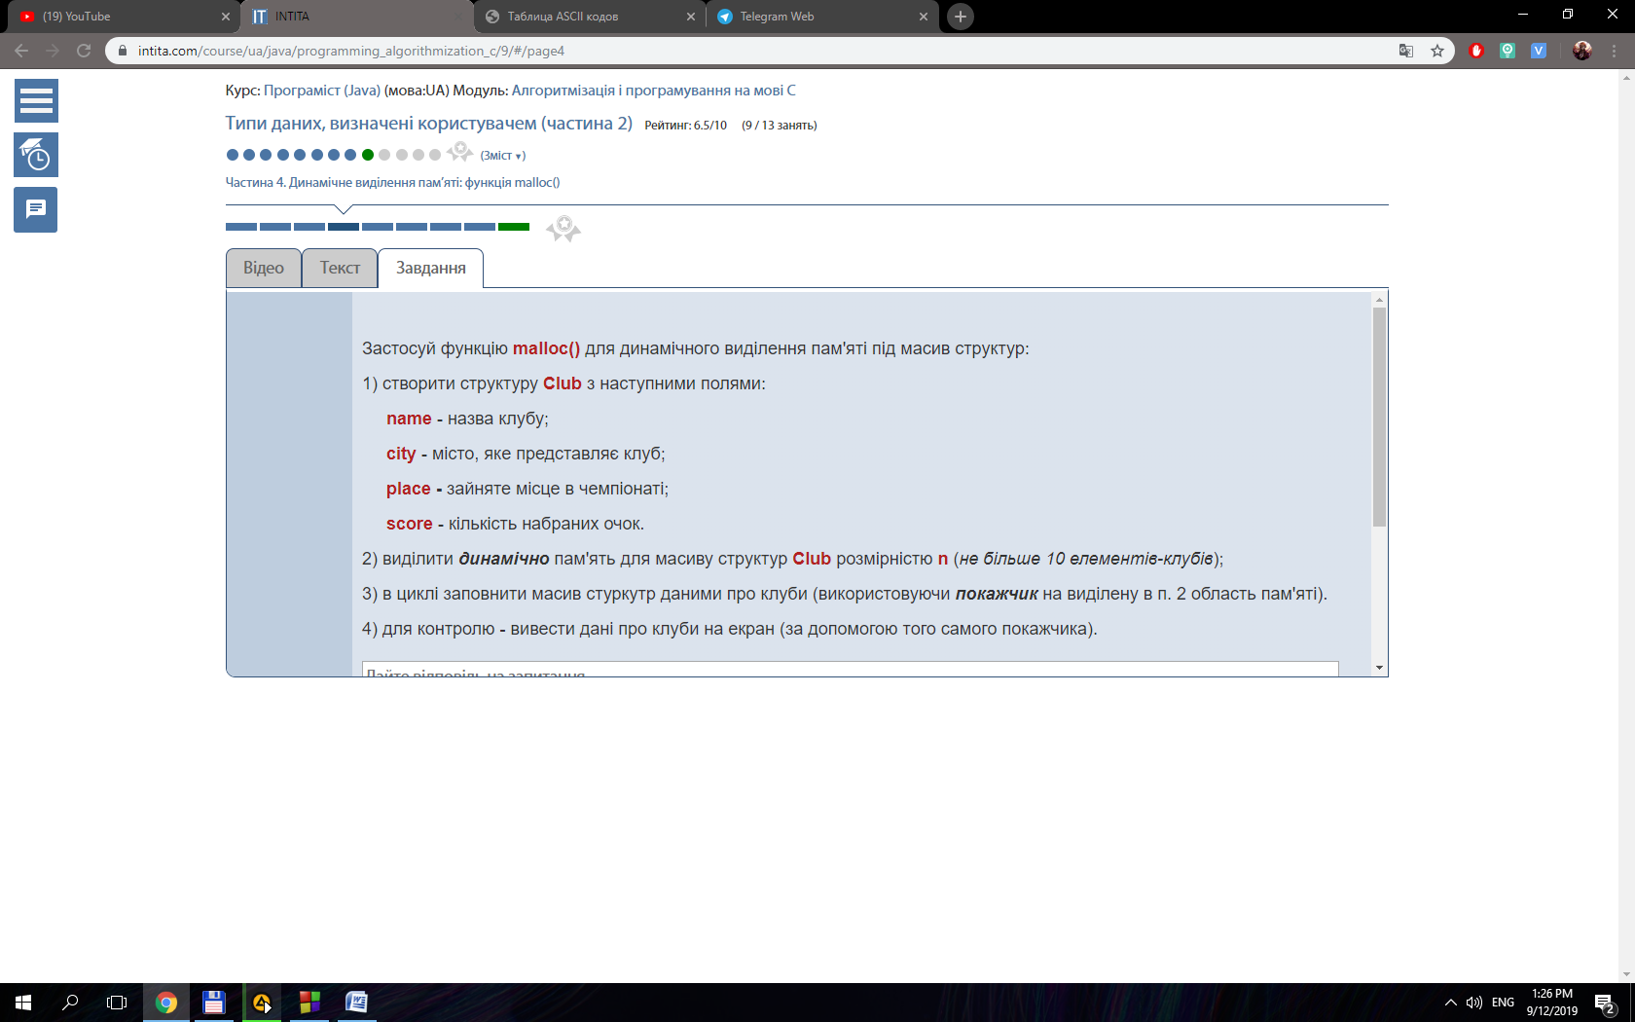

#include <stdio.h>

#include <stdlib.h>

#include <conio.h>

typedef struct {

char name [20];

char city [20];

int place;

int score;

} Club;

int main()

{

Club *teams;

int n;

do{

printf("Enter number of clubs (max 10): ");

scanf("%i", &n);

}while(n < 1 || n > 10);

teams = (Club*) calloc(sizeof(Club), n);

int i;

for (i = 0; i < n; i++){

printf("Enter date for team %i(name, place): ", i + 1);

scanf("%s %i", (teams + i)->name, &(teams + i)->place );

}

for (i = 0; i < n; i++){

printf("%s %s %i %i\n", (teams + i)->name, (teams + i)->city, (teams + i)->place, (teams + i)->score);

}

free(teams);

getch();

return 0;

}

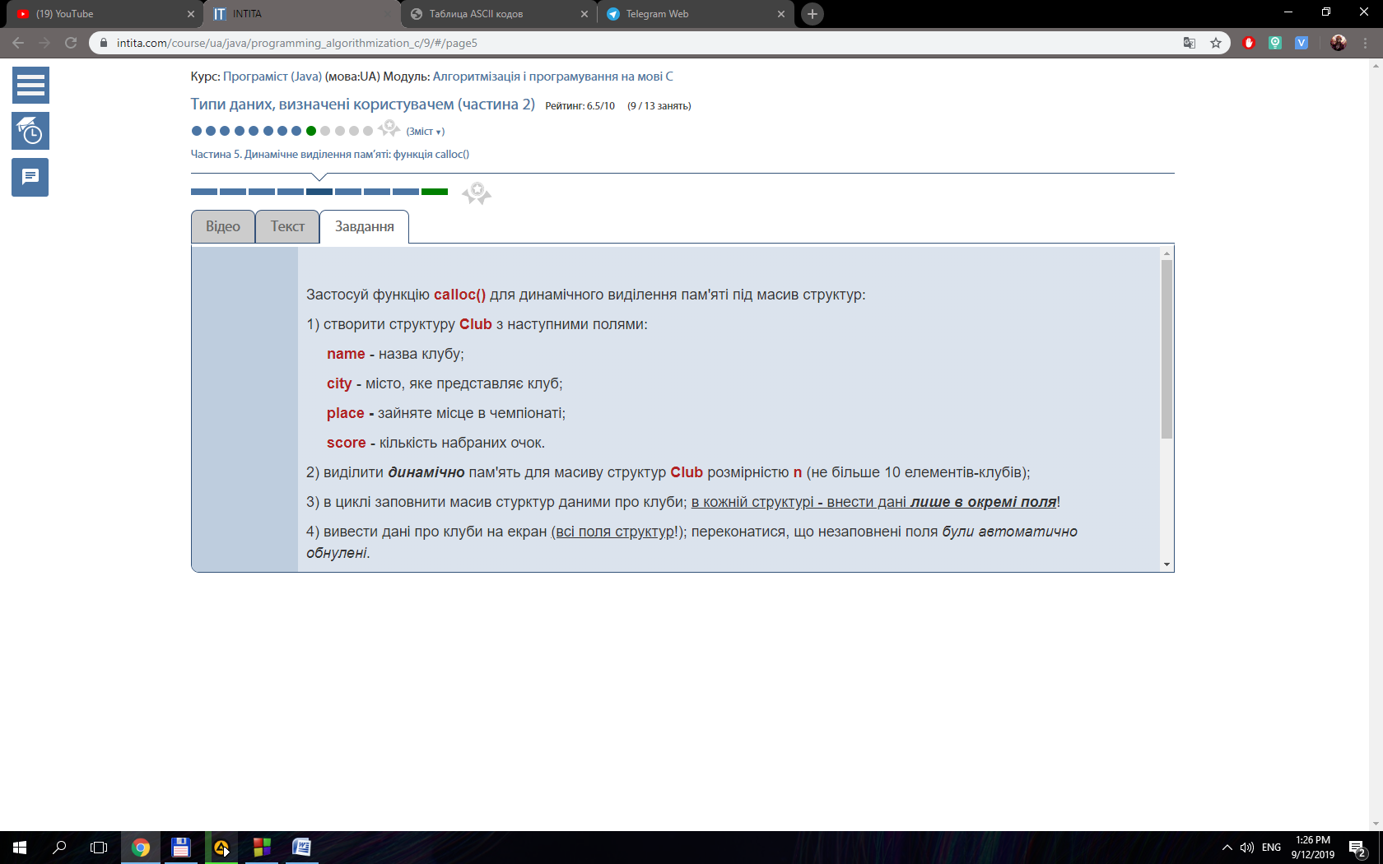

#include <stdio.h>

#include <stdlib.h>

#include <conio.h>

typedef struct

{

char name [20];

char city [20];

int place;

int score;

} Club;

int main()

{

Club *teams;

int n, i, j, min, place;

do

{

printf ( "Enter number of clubs (max 10): " );

scanf ( "%i", &n );

}

while ( n < 1 || n > 10 );

teams = ( Club* ) calloc ( sizeof ( Club ), n );

for ( i = 0; i < n; i++ )

{

printf ( "Enter date for team %i(name, town, place, score): ", i + 1 );

scanf ( "%s %s %i %i", ( teams + i )->name, ( teams + i )->city, & ( teams + i )->place, & ( teams + i )->score );

}

for ( i = 0; i < n; i++ )

{

printf ( "%s %s %i %i\n", ( teams + i )->name, ( teams + i )->city, ( teams + i )->place, ( teams + i )->score );

}

Club *teams2 ;

teams2 = ( Club* ) calloc ( sizeof ( Club ), n );

for ( i = 0; i < n; i++ )

{

* ( teams2 + i ) = * ( teams + i );

}

realloc ( teams, sizeof ( Club ) * ( n - 2 ) );

for ( i = 0; i < n - 2; i++ )

{

for ( j = 0; j < n ; j++ )

{

if ( ( teams2 + j )->place == i + 1 )

{

* ( teams + i ) = * ( teams2 + j );

}

}

}

printf("\n\n");

for ( i = 0; i < n - 2; i++ )

{

printf ( "%s %s %i %i\n", ( teams + i )->name, ( teams + i )->city, ( teams + i )->place, ( teams + i )->score );

}

free ( teams );

free ( teams2 );

getch();

return 0;

}

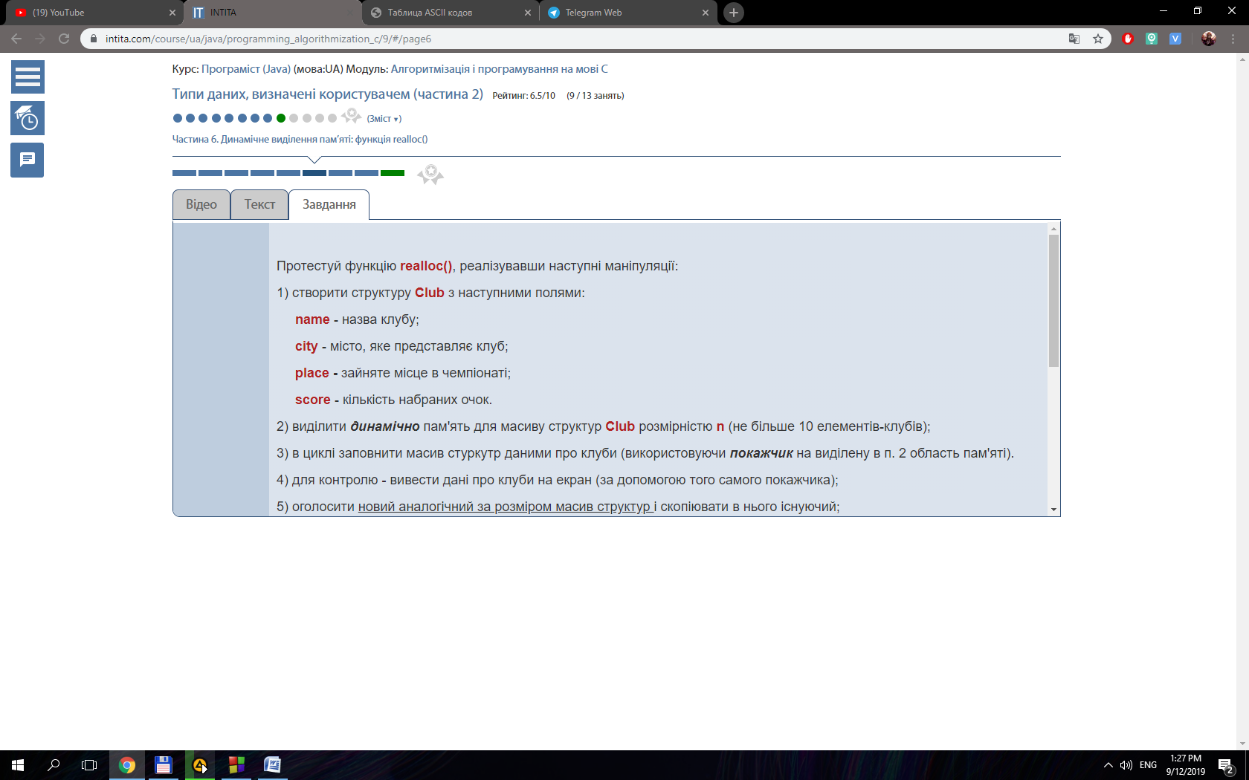

#include <stdio.h>

#include <stdlib.h>

#include <conio.h>

typedef struct

{

char name [20];

char city [20];

int place;

int score;

} Club;

int main()

{

Club *teams;

int n, i, j, min, place;

do

{

printf ( "Enter number of clubs (max 10): " );

scanf ( "%i", &n );

}

while ( n < 1 || n > 10 );

teams = ( Club* ) calloc ( sizeof ( Club ), n );

for ( i = 0; i < n; i++ )

{

printf ( "Enter date for team %i(name, town, place, score): ", i + 1 );

scanf ( "%s %s %i %i", ( teams + i )->name, ( teams + i )->city, & ( teams + i )->place, & ( teams + i )->score );

}

for ( i = 0; i < n; i++ )

{

printf ( "%s %s %i %i\n", ( teams + i )->name, ( teams + i )->city, ( teams + i )->place, ( teams + i )->score );

}

free ( teams );

printf("After free memory\n");

for ( i = 0; i < n; i++ )

{

printf ( "%s %s %i %i\n", ( teams + i )->name, ( teams + i )->city, ( teams + i )->place, ( teams + i )->score );

}

getch();

return 0;

}

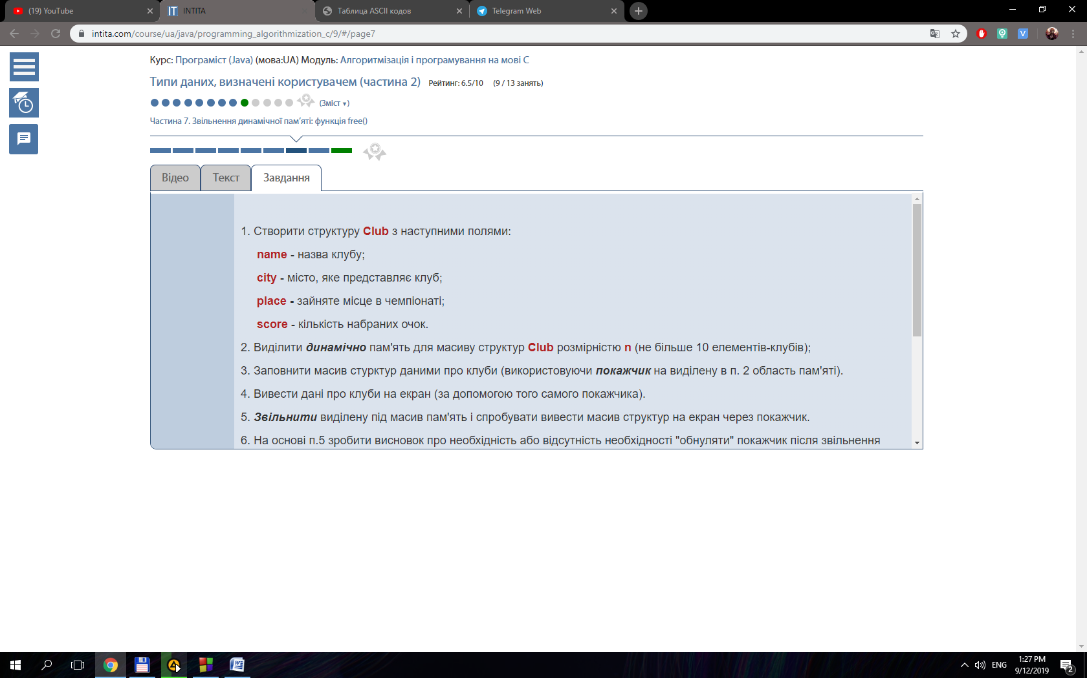

#include <iostream>

#include <cstdio>

#include <stdlib.h>

#include <string.h>

using namespace std;

typedef struct {

char name [20] ;

char city [20];

int place;

int score;

}Club;

void inputClub(char*, int*);

void inputClub(char*, char*, int*);

void inputClub(char*, char*, int*, int*);

int main()

{

int N, i, j, max = 0, plac;

do{

printf("Enter number of teams: ");

scanf ("%i", &N);

} while (N < 5); Club * teams = (Club*) calloc (sizeof(Club), N);

Club * teams1 = (Club*) calloc (sizeof(Club), N);

Club temp;

for (i = 0; i < N; i++){

inputClub ((teams + i)->name, &(teams + i)->score);

}

for (i = 0; i < N; i++){

inputClub ((teams + i)->name, (teams + i)->city, &(teams + i)->score);

}

for (i = 0; i < N; i++){

inputClub ((teams + i)->name, (teams + i)->city, &(teams + i)->score, &(teams + i)->place);

*(teams1 + i) = *(teams + i);

}

for (i = 0; i < N; i++){

max = (teams1 + i)->score;

plac = i;

for (j = i ; j < N; j++){

if ((teams1 + j)->score > max ){

max = (teams1 + j)->score;

plac = j;

}

}

temp = *(teams1 + plac);

*(teams1 + plac) = *(teams1 + i);

*(teams1 + i) = temp;

(teams1 + i)->place = i + 1;

}

for (i = 0; i < N; i++){

for (j = 0; j < N; j++){

if (strcmp ((teams + i)->name, (teams1 + j)->name) == 0 ){

(teams + i)->place = (teams1 + j)->place;

}

}

}

for (i = 0; i < N; i++){

printf("Team - %s; City - %s; Score - %i; Place - %i\n", (teams + i)->name, (teams + i)->city, (teams + i)->score, (teams + i)->place);

}

free (teams);

free (teams1);

getchar();

return 0;

}

void inputClub(char* name, int* score){

printf("Enter name of team and number of score: ");

scanf("%s %i", name, score);

}

void inputClub(char* name, char* city, int* score){

printf("Team - %s; score - %i\nEnter city of team: ", name, *score);

scanf("%s", city);

}

void inputClub(char* name, char* city, int* score, int* place){

printf("Team - %s; City - %s; Score - %i\n", name, city, *score);

}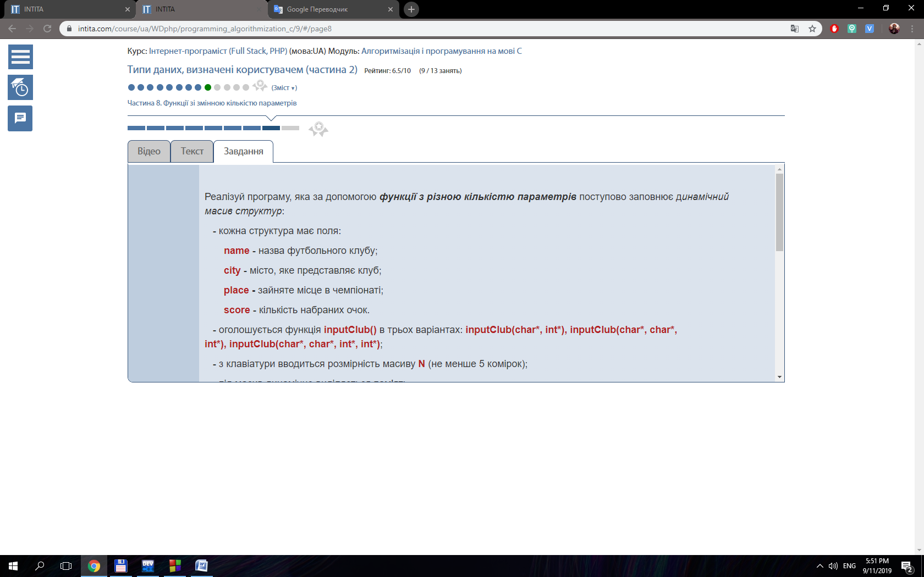

#include <stdio.h>

#include <string.h>

#include <stdlib.h>

typedef struct

{

char name [20];

char city [20];

int place;

int score;

} Clubs;

void fillStruct ( FILE *input, char* name, char* city, int* score );

void fillStruct ( FILE *input, char* name, char* city, int* score, int* place );

void fillStruct ( FILE *input, char* name, int* place );

int main()

{

int i, N = 1, n = 1;

char fileName [30], temp;

do

{

printf ( "Enter the name of file: " );

scanf ( "%s", fileName );

}

while ( strcmp ( fileName, "clubs2.txt" ) != 0 && strcmp ( fileName, "clubs1.txt" ) != 0 && strcmp ( fileName, "clubs3.txt" ) != 0 );

FILE *input = fopen ( fileName, "r" );

while ( fscanf ( input, "%c", &temp ) != EOF )

{

if ( temp == '\n' )

{

N++;

}

}

Clubs *team = ( Clubs* ) calloc ( sizeof ( Clubs ), N );

rewind ( input );

do

{

fscanf ( input, "%c", &temp );

if ( temp == ' ' )

{

n++;

}

}

while ( temp != '\n' );

rewind ( input );

switch ( n )

{

case 3:

{

for ( i = 0; i < N; i++ )

{

fillStruct ( input, ( team + i ) -> name, ( team + i ) -> city, & ( team + i ) -> score );

printf ( "%s %s %i\n", ( team + i ) -> name, ( team + i ) -> city, ( team + i ) -> score );

}

break;

}

case 4:

{

for ( i = 0; i < N; i++ )

{

fillStruct ( input, ( team + i ) -> name, ( team + i ) -> city, & ( team + i ) -> score, & ( team + i ) -> place );

printf ( "%s %s %i %i\n", ( team + i ) -> name, ( team + i ) -> city, ( team + i ) -> score, ( team + i ) -> place );

}

break;

}

case 2:

{

for ( i = 0; i < N; i++ )

{

fillStruct ( input, ( team + i ) -> name, & ( team + i ) -> place );

printf ( "%s %i\n", ( team + i ) -> name, ( team + i ) -> place );

}

break;

}

}

free ( team );

fclose ( input );

return 0;

}

void fillStruct ( FILE *input, char* name, char* city, int* score )

{

fscanf ( input, "%s %s %i", name, city, score );

}

void fillStruct ( FILE *input, char* name, char* city, int* score, int* place )

{

fscanf ( input, "%s %s %i %i", name, city, score, place );

}

void fillStruct ( FILE *input, char* name, int* place )

{

fscanf ( input, "%s %i", name, place );

}

